**Using formative assessment rubrics in Performing Arts**

Respond and Interpret in Drama

****Levels 7 and 8

Authorised and published by the Victorian Curriculum and Assessment Authority  
Level 7, 2 Lonsdale Street  
Melbourne VIC 3000

© Victorian Curriculum and Assessment Authority 2019.

No part of this publication may be reproduced except as specified under the *Copyright Act 1968* or by permission from the VCAA. Excepting third-party elements, schools may use this resource in accordance with the [VCAA educational allowance](https://www.vcaa.vic.edu.au/Footer/Pages/Copyright.aspx#schools). For more information go to: <https://www.vcaa.vic.edu.au/Footer/Pages/Copyright.aspx>.

The VCAA provides the only official, up-to-date versions of VCAA publications. Details of updates can be found on the VCAA website: [www.vcaa.vic.edu.au](http://www.vcaa.vic.edu.au).

This publication may contain copyright material belonging to a third party. Every effort has been made to contact all copyright owners. If you believe that material in this publication is an infringement of your copyright, please email the Copyright Officer: [vcaa.copyright@edumail.vic.gov.au](mailto:vcaa.copyright@edumail.vic.gov.au)

Copyright in materials appearing at any sites linked to this document rests with the copyright owner/s of those materials, subject to the Copyright Act. The VCAA recommends you refer to copyright statements at linked sites before using such materials.

At the time of publication the hyperlinked URLs (website addresses) in this document were checked for accuracy and appropriateness of content; however, due to the transient nature of material placed on the web, their continuing accuracy cannot be verified.

The VCAA logo is a registered trademark of the Victorian Curriculum and Assessment Authority.

**Contents**

What is formative assessment? 4

Using formative assessment rubrics in schools 4

The formative assessment rubric 5

Links to the Victorian Curriculum F–10 5

The formative assessment task 7

Description of the task (administration guidelines) 7

Evidence collected from this task 8

Interpreting evidence of student learning 9

Setting the scene 9

Sample 1 11

Sample 1: Evidence of student learning 11

Any feedback given 12

Sample 2 13

Sample 2: Evidence of student learning 13

Any feedback given 14

Sample 3 15

Evidence of student learning 15

Interpretation of evidence 15

Any feedback given 16

Sample 4 17

Sample 4: Evidence of student learning 18

Any feedback given 18

Sample 5 19

Sample 5: Evidence of student learning 20

Using evidence to plan for future teaching and learning 21

Teacher reflections 21

Appendices 22

Appendix 1: Assessment Tasks 22

Appendix 2: Glossary 23

What is formative assessment?

Formative assessment is any assessment that is used to improve teaching and learning. Best-practice formative assessment uses a rigorous approach in which each step of the assessment process is carefully thought through.

Assessment is a three-step process by which evidence is collected, interpreted and used. By definition, the final step of formative assessment requires a use that improves teaching and learning.

For the best results, teachers can work together to interrogate the curriculum and use their professional expertise and knowledge of their students to outline a learning continuum including a rubric of measurable, user-friendly descriptions of skills and knowledge. Teachers can draw on this learning continuum and rubric to decide how to collect evidence of each student’s current learning in order to provide formative feedback and understand what they are ready to learn next.

The VCAA’s *Guide to Formative Assessment Rubrics* outlines how to develop a formative assessment rubric to collect, interpret and use evidence of student learning to plan teaching and learning. For more information about formative assessment and to access a copy of the guide, please go to the [Formative Assessment section](https://www.vcaa.vic.edu.au/foundation10/Pages/viccurriculum/formative_assessment.aspx) of the VCAA website.

Using formative assessment rubrics in schools

This document is based on the material developed by one group of teachers in the 2019 Formative Assessment Rubrics project. The VCAA acknowledges the valuable contribution to this resource of the following teachers: Maryanne Marron (Brighton Secondary College), Katie Franzone (Catholic Regional College, Caroline Springs) and Tim Roach (Brunswick Secondary College). The Victorian Curriculum and Assessment Authority partnered with the Assessment Research Centre, University of Melbourne, to provide professional learning for teachers interested in strengthening their understanding and use of formative assessment rubrics.

This resource includes a sample formative assessment rubric, a description of a task/activity undertaken to gather evidence of learning, and annotated student work samples.

Schools have flexibility in how they choose to use this resource, including as:

* a model that they adapt to suit their own teaching and learning plans
* a resource to support them as they develop their own formative assessment rubrics and tasks.

This resource is not an exemplar.

Additional support and advice on high-quality curriculum planning is available from the [Curriculum Planning Resource](http://curriculumplanning.vcaa.vic.edu.au/).

The formative assessment rubric

The rubric in this document was developed to help inform teaching and learning in Drama. This rubric supports the explicit teaching of:

* Analyse how the elements of drama have been combined in devised and scripted drama to convey different forms, performance styles and dramatic meaning

Links to the Victorian Curriculum F–10

**Curriculum area:** Drama

Respond and Interpret strand

**Levels/Bands:** Levels 7 and 8

**Achievement standard/s extract:** By the end of Level 8, students identify and analyse how the elements of drama are used, combined and manipulated in different styles, and evaluate how they and drama practitioners from different cultures, times and locations communicate meaning and intent through drama.

**Content Description/s:** Analyse how the elements of drama have been combined in devised and scripted drama to convey different forms, performance styles and dramatic meaning [(VCADRR038)](https://victoriancurriculum.vcaa.vic.edu.au/Search?q=VCADRR038).

|  |  |  |  |  |  |  |  |
| --- | --- | --- | --- | --- | --- | --- | --- |
| **Learning continuum**  Drama  Respond and Interpret  Levels 7 and 8 | | | **Phase 1** | **Phase 2** | **Phase 3** | **Phase 4** | **Phase 5** |
| Students are able to identify dramatic elements/ conventions and their intent in performance. | Students are able to explain how dramatic elements and conventions are used in performance. | Students are able to identify performance styles and explain how performers combine elements and conventions to create dramatic meaning. | Students are able to analyse the conventions of specific performance styles, and their intended effect. | Students are able to evaluate dramatic choices. They analyse how performers employ or adapt performance styles, and how this manipulates the actor-audience relationship. |
|  |  |  |  | | | | |
| **Organising element** | **Action** | **Insufficient evidence** | **Quality criteria** | | | | |
| Respond and Interpret | 1. Analyses dramatic elements | 1.0 Insufficient evidence | 1.1 Identifies use of dramatic elements within performance. | 1.2 Links dramatic element to an example from the performance. | 1.3 Explains how dramatic elements are used and combined with other performance techniques. | 1.4 Analyses how dramatic elements are used to affect the audience. |  |
| 2. Analyses conventions | 2.0 Insufficient evidence | 2.1 Identifies use of convention/s in a performance. | 2.2 Describes an example of how a convention is used in performance. | 2.3 Explains how conventions are used and are combined with other performance techniques. | 2.4 Analyses how conventions are used to affect the audience. |  |
| 3. Links ideas to performance styles | 3.0 Insufficient evidence |  |  | 3.1 Identifies performance style/s. | 3.2 Explains how performance style is represented through the use of conventions. | 3.3 Analyses how performance style is manipulated to affect the audience. |
| 4. Discusses actor-audience relationship | 4.0 Insufficient evidence | 4.1 Identifies dramatic intent of the performance. | 4.2 Explains how the audience felt during the performance. | 4.3 Analyses how performers communicate meaning to an audience. |  | 4.4 Evaluates dramatic choices to manipulate an actor-audience relationship. |

The formative assessment task

The following formative assessment task was developed to elicit evidence of each student’s current learning and what they are ready to learn next.

Description of the task (administration guidelines)

Students were explicitly taught:

* Reflections are given in response to a performance that identifies the dramatic elements and conventions of the piece.
* Written responses should include the use of specific drama terminologies.
* There are different types of performance styles, including but not limited to: Melodrama, Greek Theatre, *Commedia dell’Arte*, Epic Theatre.
* Conventions are techniques or devices which can communicate meaning to an audience. They can help to represent specific performance styles, for example: Melodrama often uses conventions such as ‘asides’ and ‘song’.
* Dramatic elements are present in most performances, and can be manipulated for stylistic effect. They can include, but are not limited to: conflict, contrast, tension and mood.
* See [Learning in Drama](https://victoriancurriculum.vcaa.vic.edu.au/the-arts/drama/introduction/learning-in-drama) for more information on dramatic elements.

**Instructions**

* Students complete a written reflection in response to a performance they view.  This performance may be performed by students in a classroom or performed by professional actors.
* Familiarise yourself with the learning continuum, assessment rubric and teacher guidelines.
* Collect samples of reflections.
* Use the learning continuum and assessment rubric to identify students’ level of competency.

**Considerations**

* This task should take place after viewing a performance work.
* If students are unable to view live professional performances, teachers may consider performances on YouTube or other filmed work. [Australian Theatre for Young People](https://www.atypondemand.com.au/) have produced a free resource accessible to teachers and students.
* The response should be specific to a unit of work being taught. For example, the conventions being explored should be consistent with performance styles studied.
* Students may complete the task in the format that best suits their needs, for example, handwritten or typed.
* Students could respond to performance work verbally. Where this is the case, teachers should document the ideas students identify and analyse.
* Teachers may consider sharing the rubric with the students prior to the reflection activity taking place.

Evidence collected from this task

* Student reflection samples
* Written performance reviews
* Teacher notes on student discussion/reflection

Interpreting evidence of student learning

Evidence collected from each student was mapped against the rubric:

* The quality criteria that were achieved was shaded in blue.
* 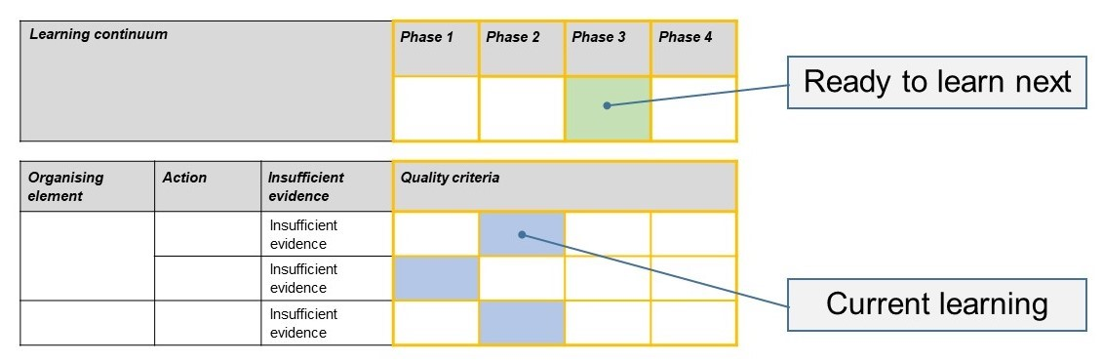The phase that the student is ready to learn next was shaded in green.

Please note, the following annotated student work samples are representative examples only.

Setting the scene

The student work samples were collected from two schools. Some were collected from a Year 8 Drama class in a co-educational Catholic Secondary School and others were collected from a Year 7 Drama class in a metropolitan co-educational government school in the inner-north of Melbourne.

For the Year 8 class, students were informed that they would be doing a written task that looked at their peers’ performance piece. The written task instructions were provided prior to writing the response in order to check that the students understood what was being asked and to clarify any language that was unfamiliar. It was important with this task that students were aware that the elements and conventions were specific to the performance style they were studying (Melodrama).

This task took 50 minutes (30 minutes of performances, 20 minutes of writing time).

For the Year 7 class, this task occurred in the context of ongoing use of drama journals as a way to capture students’ reflections on lessons, activities and workshops. The purpose of this journaling process is to help students consider the purpose of specific drama classes, and to encourage them to use drama-specific terminology in their writing, as well as to develop their abilities in responding and interpreting. Each week, specific task-related questions are uploaded to a shared network so that students can complete them in class.

Students are explicitly taught about the dramatic elements and use of conventions within a performance, and how they can be used when adapting written stories into performance work. This task occurred at the end of a process drama entitled ‘The Werewolf’, where students embody and perform specific moments from a story over a course of two weeks. A discussion occurred between the conclusion of the process drama and the written reflection process where students recapped conventions, elements and performers’ dramatic intention, and where these appeared throughout the workshops. Students were given approximately 10-15 minutes to complete this reflection.

Sample 1

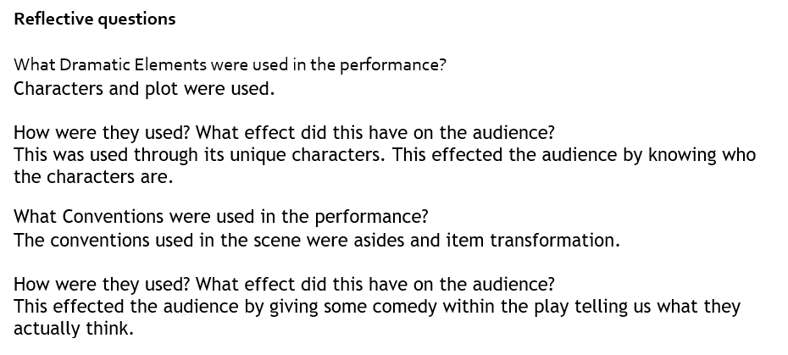Sample 1: Evidence of student learning

Annotations

* 1.1 The student identified a specific dramatic element used in a performance.
* 2.1 The student identified a convention and how they combined with performance-based techniques.
* 4.1 The student was able to identify how the performance made the audience feel.

Insufficient evidence:

* 3.0 No evidence, but on reflection we altered the task to include a question directly linked to this action in the rubric.

What is the student ready to learn next?

This student has achieved Phase 1. The student will be able to move into Phase 2 or even 3 with some more understanding on explaining and analysing performance pieces.

Any feedback given

You have reflected well on the elements and conventions used in a Melodrama performance piece. In future, consider how to use more sophisticated language in your responses. You also need to work at explaining and analysing the why and how in your reflections.

Sample 2

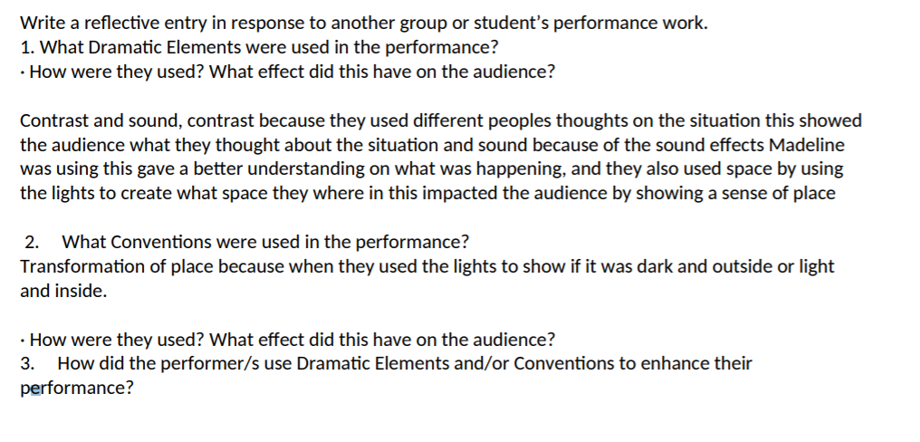Sample 2: Evidence of student learning

Annotations

* 1.3 The student was able to explain how dramatic elements are manipulated in relation to other performance techniques, for example, conventions or production areas.
* 2.1 The student has been able to describe a specific moment where performance conventions were used.
* 4.1 The student has made a link between a specific moment, and implied the performers’ intention in communicating to an audience.

Insufficient evidence:

* 3.0 No evidence provided, but on reflection we altered the task to include a question directly linked to this action in the rubric.

What is the student ready to learn next?

This student is ready to learn Phase 2 and has been able to explain how dramatic elements have been used in this performance, and they have gone into detail when discussing their examples.

Any feedback given

You have been able to explain how dramatic elements have been used in this performance, and you have gone into detail when discussing your examples. You now need to go into similar levels of detail when discussing performance conventions – for example, what effect have they had on the audience?

Sample 3

Evidence of student learning

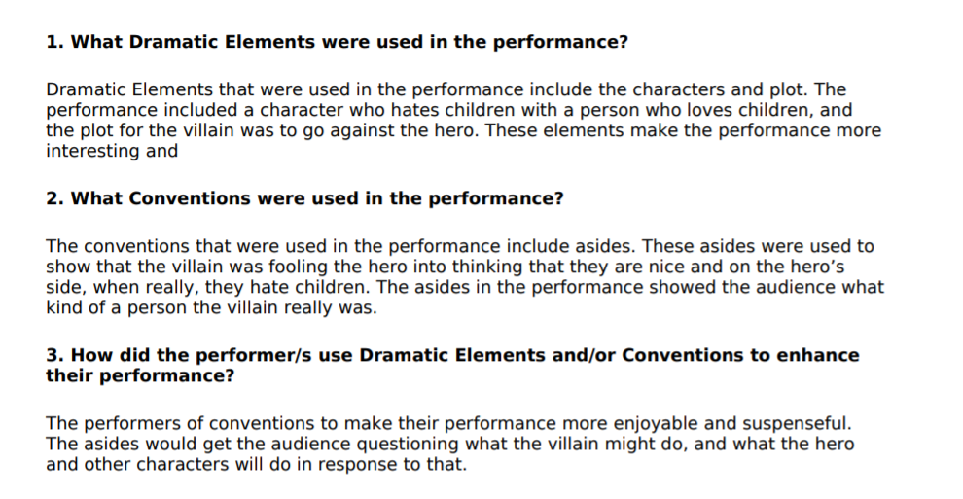Interpretation of evidence

Annotations

* 1.3 The student used clear language to explain the elements used in the performance and explained how these linked to other performance techniques.
* 2.3 The student explained the conventions and where they combined with performance-based techniques.
* 4.2 The student was able to explain how the performance made the audience feel by using linking language to elements and conventions.

Insufficient evidence:

* The student did not include the specific performance style. On reflection, we altered the task to address this so it reflects properly on the rubric. The student did know that they were watching and reflecting on a Melodrama performance style. If the student had identified the performance style, they would have achieved a 3.1 rather than a 3.0.

What is the student ready to learn next?

This student has achieved Phase 2 and identified elements of Phase 3. This student is moving towards Phase 3 or even 4 with some changes to language. The student needs to move beyond explanation into analyses of performance pieces.

Any feedback given

You have articulated your understanding of elements and conventions within a performance style. In future, work to move from explaining to analysing the performance piece.

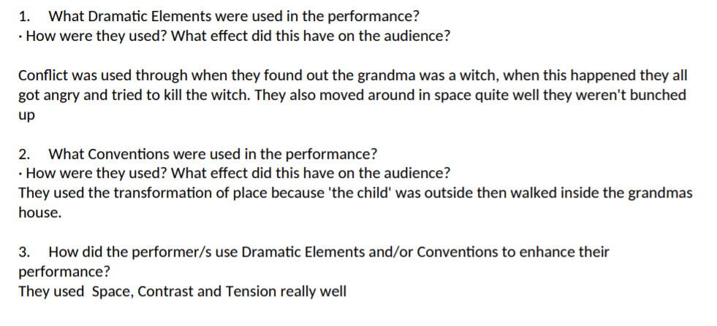Sample 4

Sample 4: Evidence of student learning

Annotations

* 1.2 The student was able to connect performers’ use of dramatic elements to specific moments from the performance.
* 2.2 The student has referred to a specific moment from the performance where a convention was used.

Insufficient evidence:

* 3.0 No evidence.
* 4.0 No evidence.

This student has used evaluative language, but has not been able to demonstrate clear use of terminology, or explain why a particular scene or performance had an impact on the audience.

This student has not identified any information about the performance style. This is indicative of beginning Level 7 Drama. We have now included information about performance styles in the Assessment Task questions, to encourage them to consider this part of the task explicitly.

What is the student ready to learn next?

This student has been able to identify the conventions and dramatic elements in the performance, with examples of where they occurred. They now need to try to link these ideas, and talk about how they made the audience feel. Further evidence is required to confirm the student is ready to learn Phase 3.

Any feedback given

You have been able to identify the conventions and dramatic elements in the performance, with examples of where they occurred. You now need to try to link these ideas, and talk about how they made the audience feel.

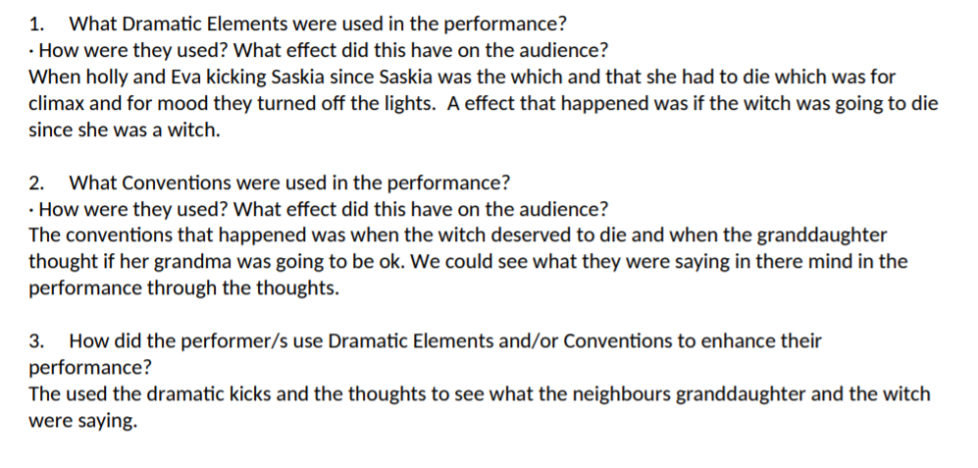Sample 5

Sample 5: Evidence of student learning

Annotations

* 1.2 The student was able to connect performers’ use of dramatic elements to specific moments from the performance.
* 4.1 The student has made a link between a specific moment, and implied the performers’ intention in communicating to an audience.

Insufficient evidence:

* 2.0 No evidence.
* 3.0 No evidence. The student has not identified any information about the performance style. This is indicative of beginning Level 7 Drama. We have now included information about performance styles in the Assessment Task questions, to encourage them to consider this part of the task explicitly.

What is the student ready to learn next?

This student has been able to discuss the use of dramatic elements in their performance, and why performers made these choices. They now need to consider performance conventions, and why they were used by performers. As insufficient evidence was provided for Actions 2 and 3, an additional learning activity will be used to check why this occurred and to confirm if the student is ready to learn Phase 2.

Any feedback given

You have been able to discuss the use of dramatic elements in their performance, and why performers made these choices. You now need to consider performance conventions, and how they were used by the performers.

Using evidence to plan for future teaching and learning

Year 7 class

* The data collected has shown that we need to embed discussion of conventions at an earlier stage to empower students to analyse their own work more confidently at an earlier level.
* While we begin talking about performance styles in Year 8, this assessment has shown us that to help extend stronger students’ learning, introducing these ideas would be a good idea.
* This assessment has reaffirmed our belief that consistently setting time aside for student discussion and writing about their practice (Responding and Interpreting) is crucial for student learning in this subject

Year 8 class

* The data helped our Performing Arts team to identify what our students are achieving in regards to reflective tools in Drama but to also identify what aspects our students could develop.

Teacher reflections

* When reflecting on the task we administered, we made some changes to the task to be more in line with the rubric and phases. No student was able to provide evidence about the specific performance style for Action 3, so we adjusted the task to include some reference to Performance styles and to explicitly remind students to discuss this.

Appendices

Appendix 1: Assessment Tasks

This learning continuum has been designed with two purposes in mind: Firstly to assess students’ ability to respond to and analyse performance work within their own classroom, and secondly, to assess students’ ability to respond to and analyse work performed by professionals.

**Assessment Task 1:**

Write a reflective entry in response to another group or student’s performance work.

1. What Dramatic Elements were used in the performance?

* How were they used? What effect did this have on the audience?

1. What Conventions were used in the performance?

* How were they used? What effect did this have on the audience?
* Does this performance fit into a specific performance style? If so, how? If not, what aspects of performance styles can you identify?

1. How did the performer/s use Dramatic Elements and/or Conventions to enhance their performance?

**Assessment Task 2:**

Write a review of the professional performance you viewed.

1. How did the performers or creative team use Conventions to communicate ideas to the audience?
2. How did the performers manipulate Dramatic Elements within the performance?
   * How were they used? What effect did this have on the audience?
3. Does this performance fit into a specific performance style? If so, how? If not, what aspects of performance styles can you identify?
4. Was this performance effective? Why/Why not?

Appendix 2: Glossary

The following glossary terms have been extracted from The Arts Glossary – Drama.

**Audience/s**

Individuals or groups of people who experience the arts in a range of settings and contexts (formal, informal, virtual or interactive) through intellectual, emotional and social engagement. The artist is audience to their own artwork.

**Character**

The qualities of a work or performance that communicate tone, mood and/or feeling.

In Drama, identification and portrayal of a person’s values, attitudes, intentions and actions as imagined relationships, situations and ideas in dramatic action.

**Conventions**

Traditional, stylistically or culturally accepted ways of doing things. Each art form has hundreds of conventions built up over time. Conventions are dynamic and ever-changing.

In Drama, conventions can refer to techniques or devices incorporated into a performance. These help to communicate the style of a performance. Conventions may include: asides, placards, use of song, mime, etc.

**Dramatic action**

The driving force and forward motion of drama to create dramatic meaning, tension, belief and audience engagement. The movement of the drama from the introduction, exposition of ideas and conflict to a resolution.

**Dramatic meaning**

A signified, intended purpose or effect interpreted from the communication of expressive dramatic action.

**Elements of drama**

Role, character and relationships:

*Role and character:* identification and portrayal of a person’s values, attitudes, intentions and actions as imagined relationships, situations and ideas in dramatic action; role focus on type and stereotype; characters are detailed and specific.

*Relationships:* the connections and interactions between people that affect the dramatic action.

*Situation:* the setting and circumstances of the dramatic action – the who, what, where, when and what is at stake of the roles/characters.

Voice and movement:

*Voice:* using voice expressively to create roles, situations, relationships, atmosphere and symbols

*Movement:* using facial expression, posture and action expressively in space and time to create roles, situations, relationships, atmosphere and symbols.

*Focus:* directing and intensifying attention and framing moments of dramatic action.

*Tension:* sense of anticipation or conflict within characters or character relationships, or problems, surprise and mystery in stories and ideas to propel dramatic action and create audience engagement.

Space and time:

*Space:* the physical space of the performance and audience, fictional space of the dramatic action and the emotional space between characters.

*Time:* fictional time in the narrative or setting; timing of one moment to the next contributing to the tension and rhythm of dramatic action.

Language, ideas, dramatic meaning, mood and atmosphere, and symbol:

*Language, ideas and dramatic meaning*: the choice of linguistic expression and ideas in drama used to create dramatic action

*Mood and atmosphere:* the feeling or tone of both the physical space and the dramatic action created by or emerging from the performance

*Symbol:* associations that occur when something is used to represent something else to reinforce or extend dramatic meaning

**Expressive skills**

In Drama, is the use of skills such as voice, facial and vocal expression to communicate in performance.

**Focus**

To concentrate the attention on a spatial direction or a point in space to intensify attention or increase the projection of intent. For example:

* in Drama, directing and intensifying attention and framing moments of dramatic action or identifying the main idea of the drama

**Forms**

In each Arts subject, form is the whole of an artwork created by the elements and/or materials and the way they are structured:

* in Drama, form is the way drama is structured. Drama forms are shaped by the application of the elements of drama within particular social, cultural and historical contexts

**Improvisation**

Creative activity applying the elements of an arts discipline, spontaneously or in response to a given stimulus or structure.

In Drama, enactment taking on roles and situations to create dramatic action and extend an idea; can be used to create a drama or as part of a development process

**Performance skills**

In Drama, performance skills are used by a performer to enhance performance and create an actor’s presence. They include energy, focus, timing, and the ability to manipulate the actor/audience relationship

**Performance style**

A type of expression communicated for a particular effect with distinguishing features and appearance, performance styles are defined by the way conventions and other elements are used in performance.

**Play-building**

Creating a play through improvisation or devising.

**Practice/s**

The application of Arts skills and knowledge to create, represent, communicate and respond in a specific arts discipline, form, tradition, style and/or genre. For example, in any Arts discipline, the practices of making and responding are interdependent and interactive. For example, the practices of interpreting, comparing and contrasting, reflecting, analysing, appreciating and evaluating can inform a making process but can also be used independently.

In Dance, choreography, performance and appreciation, improvisation, rehearsal, refinement.

In Drama, improvising, devising, playing, acting, directing, refining, scripting, practising, rehearsing, presenting and performing.

**Process drama**

A method of teaching and learning drama where both the students and teacher are working in and out of role.

**Projection**

In Drama, the loudness of the voice of an actor, and how it is carried to the audience.

**Purposeful play**

Is a context for learning through which children organise and make sense of their social worlds, as they engage actively with people, objects and representations.

**Representation**

In Drama, Media Arts and Visual Arts, the expression or designation of a character, place, idea, image or information by some other term, character, symbol, diagram, image, sound or combination of visual and aural expression, based on shared social values and beliefs.

**Rhythm**

In Drama, the emotional rhythm or flow of a performance work. This may refer to the pace of a performance, line delivery, scene transitions, or length of scenes.

**Role**

Adopting identification and portrayal of a person’s values, attitudes, intentions and actions and portraying these as imagined relationships, situations and ideas in dramatic action.

**Role-play**

To pretend to be someone else.

**Scene**

The dramatic action that occurs in a particular time and place; a section of a play.

**Technique**

In Drama, techniques include ways of using voice and movement to create role and dramatic action; also techniques in lighting, sound, set building and painting, costume making, and make-up.

**Tone**

In Drama, tone of voice.

**Viewpoints**

A collection of perspectives, lenses or frames through which artworks can be explored and interpreted.