Using formative assessment rubrics in Languages

Italian
Levels 3–6

Authorised and published by the Victorian Curriculum and Assessment Authority
Level 7, 2 Lonsdale Street
Melbourne VIC 3000
© Victorian Curriculum and Assessment Authority 2020.

No part of this publication may be reproduced except as specified under the Copyright Act 1968 or by permission from the VCAA. Excepting third-party elements, schools may use this resource in accordance with the VCAA educational allowance. For more information go to: https://www.vcaa.vic.edu.au/Footer/Pages/Copyright.aspx.
The VCAA provides the only official, up-to-date versions of VCAA publications. Details of updates can be found on the VCAA website: www.vcaa.vic.edu.au.
This publication may contain copyright material belonging to a third party. Every effort has been made to contact all copyright owners. If you believe that material in this publication is an infringement of your copyright, please email the Copyright Officer: vcaa.copyright@edumail.vic.gov.au
Copyright in materials appearing at any sites linked to this document rests with the copyright owner/s of those materials, subject to the Copyright Act. The VCAA recommends you refer to copyright statements at linked sites before using such materials.
At the time of publication the hyperlinked URLs (website addresses) in this document were checked for accuracy and appropriateness of content; however, due to the transient nature of material placed on the web, their continuing accuracy cannot be verified.

The VCAA logo is a registered trademark of the Victorian Curriculum and Assessment Authority.

Contents
The formative assessment rubric 5
Links to the Victorian Curriculum F–10 5
The formative assessment task 7
Description of the task (administration guidelines) 7
Interpreting evidence of student learning 9
Setting the scene 9
Sample 1 10
Sample 2 12
Sample 3 14
Using evidence to plan for future teaching and learning 16
Teacher reflections 16

What is formative assessment?
Formative assessment is any assessment that is used to improve teaching and learning. Best-practice formative assessment uses a rigorous approach in which each step of the assessment process is carefully thought through.
Assessment is a three-step process by which evidence is collected, interpreted and used. By definition, the final step of formative assessment requires a use that improves teaching and learning.
For the best results, teachers can work together to interrogate the curriculum and use their professional expertise and knowledge of their students to outline a learning continuum including a rubric of measurable, user-friendly descriptions of skills and knowledge. Teachers can draw on this learning continuum and rubric to collect evidence of each student’s current learning in order to provide formative feedback and understand what they are ready to learn next.
The VCAA’s Guide to Formative Assessment Rubrics outlines how to develop a formative assessment rubric to collect, interpret and use evidence of student learning to plan teaching and learning. For more information about formative assessment and to access a copy of the guide, please go to the Formative Assessment section of the VCAA website.

Using formative assessment rubrics in schools
This document is based on the material developed by one group of teachers in the 2019 Formative Assessment Rubrics project. The VCAA acknowledges the valuable contribution to this resource of the following teachers: Emilia Iaconis (Morang South Primary School), Linda Marani (Seabrook Primary School), and Jessica Piraina (Mill Park Primary School). The Victorian Curriculum and Assessment Authority partnered with the Assessment Research Centre, University of Melbourne, to provide professional learning for teachers interested in strengthening their understanding and use or formative assessment rubrics.
This resource includes a sample formative assessment rubric and task and describes how the teachers implemented the task in their schools and also includes representative student work samples.
Schools have flexibility in how they choose to use this resource, including as:
- a model that they adapt to suit their own teaching and learning plans
- a resource to support them as they develop their own formative assessment rubrics and tasks.
This resource is not an exemplar. Schools are advised to consider whether the sample formative assessment rubric and task meet the needs of their student cohort and is appropriate in the context of their whole-school teaching and learning plan. Additional support and advice on high-quality curriculum planning is available from the Curriculum Planning Resource.

The formative assessment rubric
The rubric in this document was developed by three Victorian teachers to help inform teaching and learning in Italian. This rubric supports the development of written texts, from written sentence fragments to a combination of simple and compound sentences.
This formative assessment rubric is designed to be used in conjunction with the formative assessment task.

Links to the Victorian Curriculum F–10

Curriculum area: Languages, Italian
Strand: Understanding, Sub-strand: Systems of Language
Strand: Communicating, Sub-strand: Socialising
Levels: 3–6
Achievement standards extracts: Levels 3 and 4
Students create written texts of a few sentences using familiar language and grammatical structures. … They build understanding of Italian grammatical rules, such as the fact that nouns have masculine or feminine gender and singular and plural forms, and that nouns, adjectives and articles need to agree.
Levels 5 and 6
Students create sentences with some elaboration, for example, using coordinating conjunctions and comparisons to build short coherent texts on familiar topics … They write descriptions, letters, messages, summaries, invitations and narratives. They use the present tense of verbs, noun and adjective agreements and some adverbs; they choose vocabulary appropriate to the purpose of the interaction, such as to describe, to plan or to invite.
Content descriptions: Levels 3 and 4 – Recognise how grammatical structures are used to form simple texts (VCIT7034)
Levels 5 and 6 – Use grammatical knowledge, to interpret and create meaning in Italian (VCITU052)
Levels 5 and 6 – Interact to share interests, leisure activities, feelings, opinions and preferences (VCITC039)

Learning continuum  Languages, Italian, Levels 3–6  Strand: Understanding. Sub-strand: Systems of Language  Strand: Communicating. Sub-strand: Socialising | Phase 1 | Phase 2 | Phase 3 | Phase 4
 | Students write simple sentences or sentence fragments, using nouns, articles and adjectives to convey meaning. | Students write sentences, correctly using nouns, regular adjectives and articles that agree in gender and quantity. | Students write a combination of simple and compound sentences, correctly using nouns, regular and irregular adjectives and articles that agree in gender and quantity. | Students write a combination of simple and compound sentences using various conjunctions, correctly using nouns, regular and irregular adjectives and articles that agree in gender and quantity.

Organising element | Action | Insufficient evidence | Quality criteria
Sentence structure | 1. Writes simple sentences | 1.0 Insufficient evidence | 1.1 Uses a noun and verb in a simple sentence |  | .
 | 2. Writes compound sentences | 2.0 Insufficient evidence |  | 2.1 Uses the connective ‘and’ (e) when listing (e.g. I like green, red and blue) | 2.2 Connects two simple sentences using a conjunction (e.g. e/and, con/with, o/or) to connect ideas | 2.3 Writes a combination of simple and compound sentences by selecting an appropriate conjunction (e.g. e/and, con/with, o/or) to connect ideas
 | 3. Write articles that agree with the gender and quantity of the noun | 3.0 Insufficient evidence | 3.1 Matches articles with the gender of the noun | 3.2 Matches articles with the gender and quantity of the noun
 | 4. Writes using adjectives that agree with the gender and quantity of the noun | 4.0 Insufficient evidence | 4.1 Places the adjectives after the noun | 4.2 Writes sentences matching regular adjectives with the gender and quantity of the noun | 4.3 Writes sentences matching regular and irregular adjectives with the gender and quantity of the noun

The formative assessment task
The following formative assessment task was developed to elicit evidence of each student’s current learning and what they are ready to learn next.

Description of the task (administration guidelines)

Three different formative assessment tasks were set for three different classes.

Task A – Years 3 and 4 class
- This formative assessment task can be undertaken during a sequence of work focusing on written language. The task is introduced to the students after explicitly teaching content related to grammatical structures and content related to the story La Macchinetta Rossa.
- Students are provided with the rubric criteria and the criteria is modelled to the class as a whole.
- Students complete the formative assessment task within a 60-minute session.
- At the beginning of the task the teacher explains the task again and reads the following statement:
Today I would like you to write sentences about your Macchinetta.
I would like you to use the language and sentence structures that we have been looking at and using during our unit on ‘Travelling to Italy’.
Also use the rubric and our template to help guide you and to remind you of your success criteria for the task.
I am asking you to do this so I can look at how you are using sentences to create interesting writing in Italian. We are going to use this information to develop our writing skills by using different types of sentences.
Please complete this task on your own, and if you need help please use the language around the room and other things, such as bilingual dictionaries.
Use the blank picture of the car and La Macchinetta Rossa to help you draw on your prior knowledge of familiar language/vocabulary.

Task B – Year 4 class
- This formative assessment written task can be completed by a class of Year 4 students. The task is introduced to the students after they have been immersed in the language surrounding the topics of Il corpo (The body), Le carateristiche (Characteristics) and I vestiti (Clothing). Within these topics, students will have been explicitly taught content relating to the sentence structure including use or definite articles, conjunctions and adjectives.
- Prior to the writing component of the task, students will have used a body template to illustrate a character wearing three or more types of clothing of varying colours.
- Students complete the formative assessment task within a 45-minute session.

- After explaining the task to students, the teacher reads the following statement:
Today I would like you to independently write text describing your illustration. You may like to describe the facial features, clothing or both. I am asking you to do this so I can look at how you are using adjectives and conjunctions to create interesting writing. We are then going to use this information to further develop our writing skills. It is important that you complete this task independently and try your best.

Task C – Year 6 class
- This formative assessment task can be undertaken by a Year 6 class during a sequence of work focusing on written language.
- The task is introduced to the students after explicitly teaching content related to sentence structure, in particular:
- simple and compound sentences
- the agreement in gender and quantity between articles and nouns and adjectives and nouns/
- Students complete the formative assessment task within a 60-minute session.
- At the beginning of the task, the teacher explains the task and reads the following statement:
Today, I would like you to write a text describing yourself, using a mix of simple and compound sentences, matching articles and adjectives with nouns.
You will need to work da solo e da sola (independently).
I am asking you to do this so I can look how you are using grammatical structures to make your writing more interesting. We are going to use this information to further develop our writing skills.

Evidence collected from this task
Written work samples

Interpreting evidence of student learning
Evidence collected from each student was mapped against the rubric:
- The quality criteria that were achieved was shaded in blue.
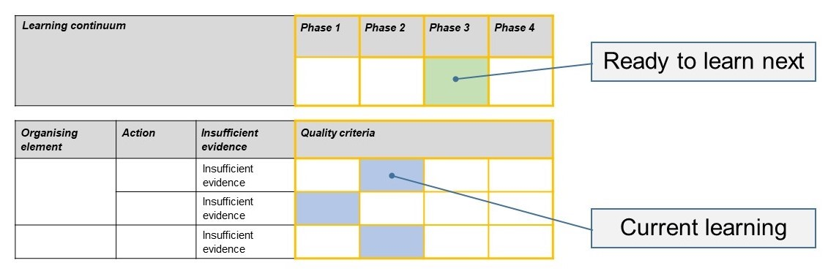
- The phase that the student is ready to learn next was shaded in green.

Please note, the following annotated student work samples are representative examples only.

Setting the scene
The formative assessment tasks were carried out in each of three different government primary schools, two of which are in metropolitan Melbourne and one of which is in regional Victoria.
Each school conducted a slightly different task (Tasks A, B or C).

Sample 1
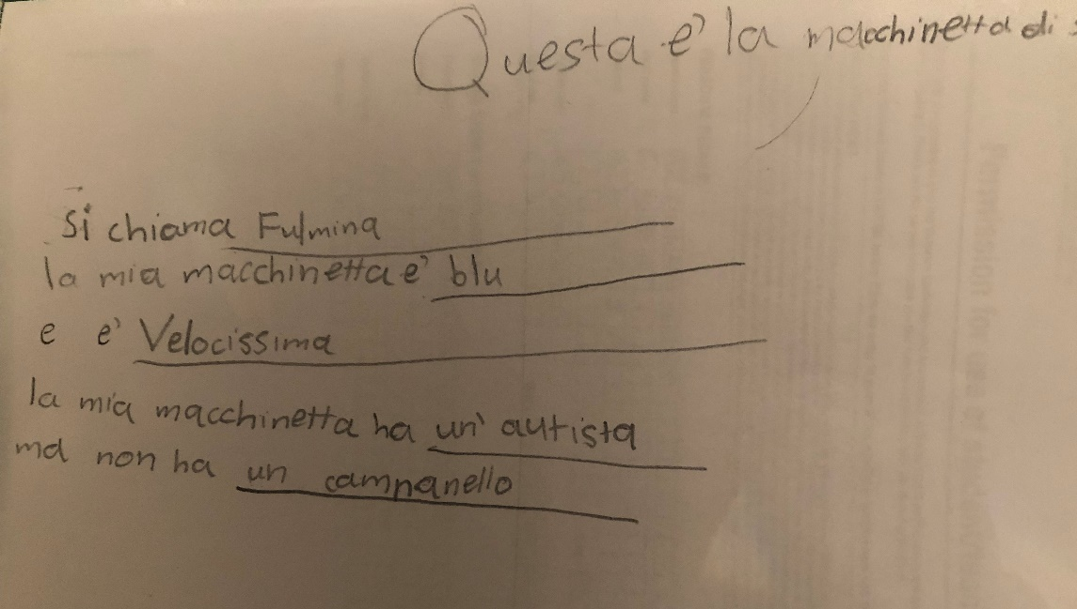

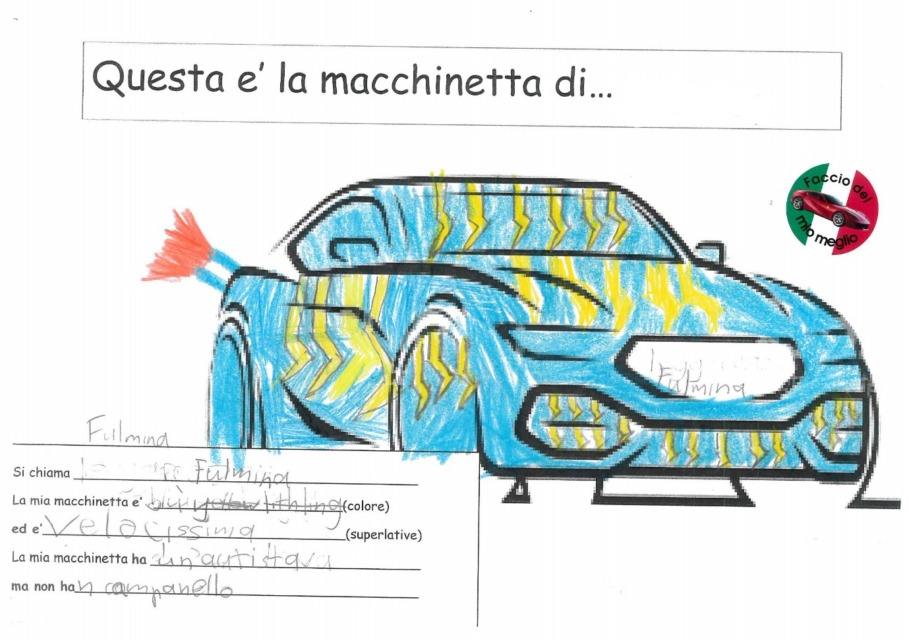

Sample 1: Evidence of student learning

Annotations
- 1.1 – Uses a noun and verb in a simple sentence. La mia macchinetta ha un autista
- 3.2 – Matches articles with the gender and quantity of the noun. La mia macchinetta è blu
- 4.2 – Writes sentences matching regular adjectives with the gender and quantity of the noun. La mia macchinetta è velocissima
Insufficient evidence:
- 2.0 – There was insufficient evidence to indicate if the student can use the connective e (and) when listing (e.g. I like green, red and blue) and/or write compound sentences.

What is the student ready to learn next?
The student was assessed as ready to learn Phase 2 next, with a focus on using the connective e (and) when listing and attempting to write simple and compound sentences.
The student will be immersed in writing activities that will be carefully scaffolded in order to gauge his understanding of the grammatical features being taught.
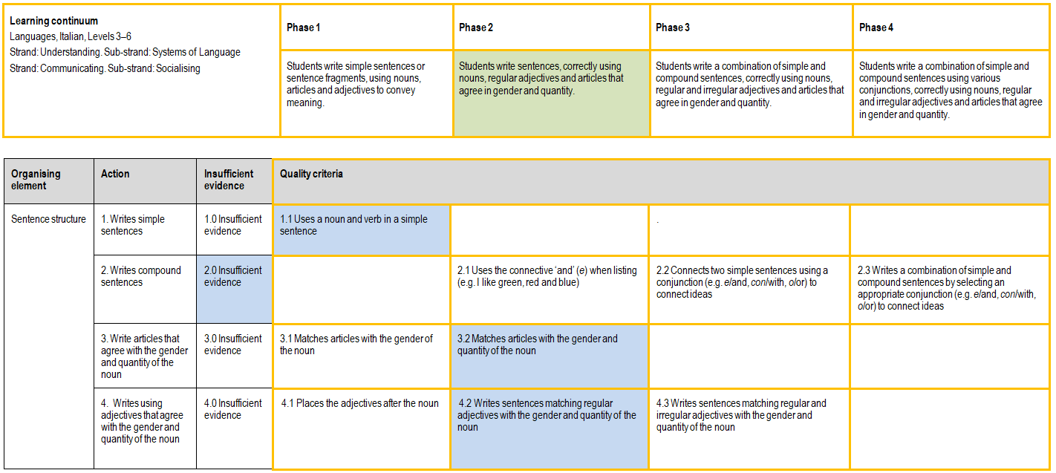

Any feedback given
The student was told: You have listened to the task and you have demonstrated a sound understanding of what was asked. In future writing, you could try to use e (and) to list more than one item. Bravo on your achievements.

Sample 2

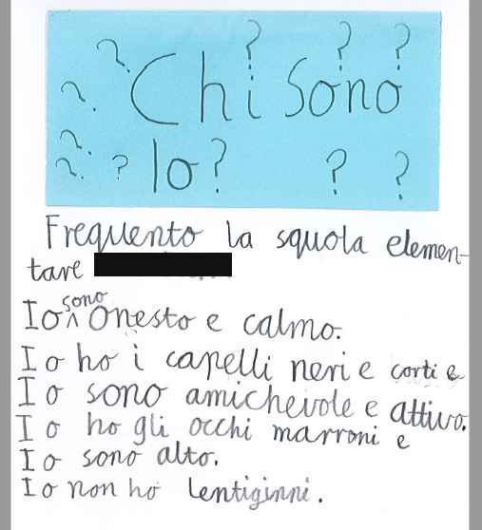

Sample 2: Evidence of student learning

Annotations
- 1.1 – Student has demonstrated his ability to use a noun and a verb in a simple sentence multiple times, for example Io sono onesto. Io non ho lentiggini.
- 2.2 – Student has demonstrated his ability to use e (and) as a conjunction, for example Io ho gli occhi marroni e io sono alto.
- 3.2 – Student is able to match articles with singular and plural nouns, for example i capelli / gli occhi.
- 4.3 – Student uses regular and irregular adjectives, for example amichevole and marroni.

What is the student ready to learn next?
The student was assessed as ready to learn Phase 4 next. He has demonstrated a sound understanding of Phases 1–3, and he is ready to start experimenting with the use of comparative connectives such as ma (but) and o (or).
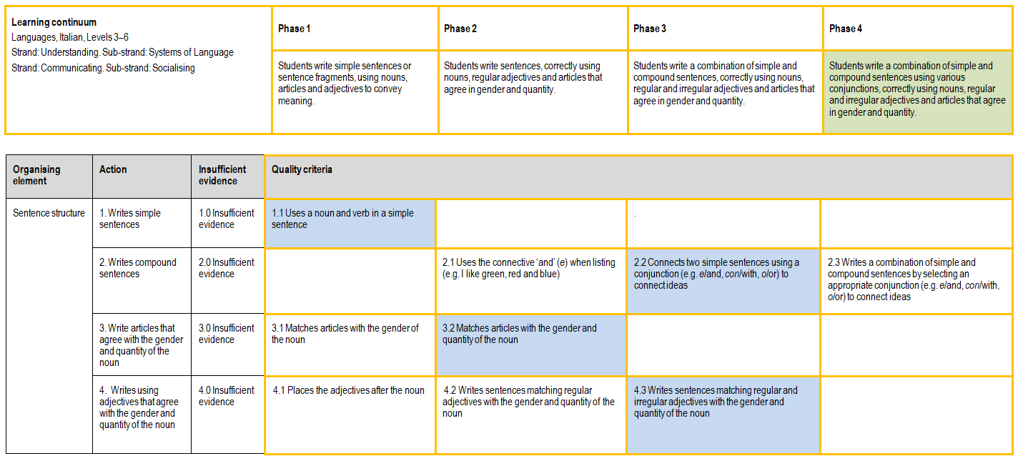

Any feedback given
The student was told: You have really mastered matching adjectives with nouns and articles. Your new goal is to start using connectives other than ‘and’, and then to try and use these new connectives to make compound sentences.

Sample 3

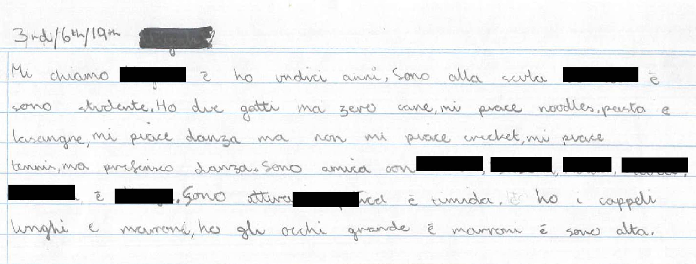

Sample 3: Evidence of student learning

Annotations
- 1.1 – Student uses a noun and verb in a simple sentence, for example Sono attiva, simpatica e timida (I am active, funny and shy).
- 2.3 – Student writes a combination of simple and compound sentences, for example Mi chiamo [redacted] e ho 11 anni (My name is [redacted] and I’m 11 years old) and Mi piace danza, ma non mi piace cricket (I like dancing, but I don’t like cricket).
- 3.2 – Student matches articles with gender and quantity of noun, for example Ho i capelli lunghi e marroni (I have long brown hair).
- 4.3 – Student writes sentences matching regular and irregular adjectives with the gender and quantity of the noun, for example Ho i capelli lunghi e marroni (I have long brown hair).

What is the student ready to learn next?
This student has clearly achieved the highest phase on this rubric. An extended rubric and a more challenging task is required to show what the student is ready to learn next.
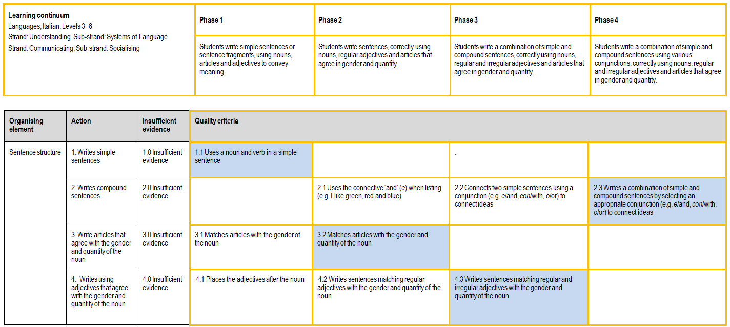

Any feedback given
The student was told: Great work. Your writing has exceeded expectations! Next step would be to not miss articles in front of every noun and to check that plurals of nouns are correct in 100% of cases.

Using evidence to plan for future teaching and learning
The data gathered from the formative assessment task revealed any inconsistencies among the cohort and helped to pinpoint areas for improvement and areas that required further teaching.
This information will help in our planning for teaching small groups and targeting specific skills. It has helped to identify where a particular skill needs to be further scaffolded.

Teacher reflections
Formative assessment tasks are being discussed at our school and are regarded as the way forward in assessing specific areas and integrating formative assessment into our planning and teaching. Every curriculum area will benefit from this approach.
I will use this rubric again, but I will give it to the students at the beginning of the unit, in order to improve student agency and learning ownership.
Reflecting on the rubric and task, if I were to make any adjustments it would be to make the criteria more specific and to include fewer criteria for assessment.

