Using formative assessment rubrics in Languages

Japanese
Levels 5–8

Authorised and published by the Victorian Curriculum and Assessment Authority
Level 7, 2 Lonsdale Street
Melbourne VIC 3000
© Victorian Curriculum and Assessment Authority 2020.

No part of this publication may be reproduced except as specified under the Copyright Act 1968 or by permission from the VCAA. Excepting third-party elements, schools may use this resource in accordance with the VCAA educational allowance. For more information go to: https://www.vcaa.vic.edu.au/Footer/Pages/Copyright.aspx.
The VCAA provides the only official, up-to-date versions of VCAA publications. Details of updates can be found on the VCAA website: www.vcaa.vic.edu.au.
This publication may contain copyright material belonging to a third party. Every effort has been made to contact all copyright owners. If you believe that material in this publication is an infringement of your copyright, please email the Copyright Officer: vcaa.copyright@edumail.vic.gov.au
Copyright in materials appearing at any sites linked to this document rests with the copyright owner/s of those materials, subject to the Copyright Act. The VCAA recommends you refer to copyright statements at linked sites before using such materials.
At the time of publication the hyperlinked URLs (website addresses) in this document were checked for accuracy and appropriateness of content; however, due to the transient nature of material placed on the web, their continuing accuracy cannot be verified.

The VCAA logo is a registered trademark of the Victorian Curriculum and Assessment Authority.

Contents
What is formative assessment? 4
Using formative assessment rubrics in schools 4
The formative assessment rubric 5
Links to the Victorian Curriculum F–10 5
Setting the scene 8
Sample 1 9
Sample 2 11
Sample 3 13
Using evidence to plan for future teaching and learning 15
Teacher reflections 15

What is formative assessment?
Formative assessment is any assessment that is used to improve teaching and learning. Best-practice formative assessment uses a rigorous approach in which each step of the assessment process is carefully thought through.
Assessment is a three-step process by which evidence is collected, interpreted and used. By definition, the final step of formative assessment requires a use that improves teaching and learning.
For the best results, teachers can work together to interrogate the curriculum and use their professional expertise and knowledge of their students to outline a learning continuum including a rubric of measurable, user-friendly descriptions of skills and knowledge. Teachers can draw on this learning continuum and rubric to collect evidence of each student’s current learning in order to provide formative feedback and understand what they are ready to learn next.
The VCAA’s Guide to Formative Assessment Rubrics outlines how to develop a formative assessment rubric to collect, interpret and use evidence of student learning to plan teaching and learning. For more information about formative assessment and to access a copy of the guide, please go to the Formative Assessment section of the VCAA website.

Using formative assessment rubrics in schools
This document is based on the material developed by one group of teachers in the 2019 Formative Assessment Rubrics project. The VCAA acknowledges the valuable contribution to this resource of Showji Ito (Viewbank Primary School). The Victorian Curriculum and Assessment Authority partnered with the Assessment Research Centre, University of Melbourne, to provide professional learning for teachers interested in strengthening their understanding and use or formative assessment rubrics.
This resource includes a sample formative assessment rubric and task and describes how the teachers implemented the task in their schools and also includes representative student work samples.
Schools have flexibility in how they choose to use this resource, including as:
- a model that they adapt to suit their own teaching and learning plans
- a resource to support them as they develop their own formative assessment rubrics and tasks.
This resource is not an exemplar. Schools are advised to consider whether the sample formative assessment rubric and task meet the needs of their student cohort and is appropriate in the context of their whole-school teaching and learning plan. Additional support and advice on high-quality curriculum planning is available from the Curriculum Planning Resource.
.

The formative assessment rubric
The rubric in this document was developed by a Victorian Japanese teacher to help inform teaching and learning in Japanese. It supports the explicit teaching of writing sentences in Japanese and extending sentences to include more information.
This formative assessment rubric is designed to be used in conjunction with the formative assessment task to provide teachers with information regarding a student’s ability to:
- write responses to match a given picture
- provide accurate words to help describe an item
- use appropriate stroke order when writing in Japanese.

Links to the Victorian Curriculum F–10
Curriculum area: Languages – Japanese
Communicating and Understanding strands
Band: Levels 5 and 6
Achievement standard extracts: [Students] respond to questions in familiar contexts using complete sentences …
extend their answers by using conjunctions such as そして、それから …
Students locate specific information and some supporting details in a [written text] …
They express reactions to imaginative texts, such as by describing qualities of characters, for example, やさしい人です。
They apply their knowledge of stroke order to form characters.
Content description/s: Communicating Strand, Informing Sub – strand
Convey information on specific topics using formats such as oral or digital presentations, displays, diagrams, timelines and guided descriptions.
Communicating Strand, Translating sub – strand
Explain aspects of spoken, written and non – verbal communication in Japanese interactions that require interpretation and require cultural meaning.
Understanding Strand, Systems of language sub – strand
Engage with authentic spoken language, recognising how words blend and understanding the relationship between sounds, words and meaning.

Learning continuum  Languages, Japanese, Levels 5 and 6  Strand: Communicating  Sub-strands: Informing, Translating |  |  | Phase 1 | Phase 2 | Phase 3 | Phase 4 | Phase 5
 |  |  | Student writes simple sentences to convey meaning. | Student writes grammatically correct simple sentences to convey meaning. | Student writes various simple sentences using different vocabularies to provide factual information. | Student writes a combination of simple and compound sentences, mainly in the Japanese writing script, to convey meaning. | Student writes passages based on the question, combining simple and complex sentences in Japanese writing script correctly to describe someone.
Organising element | Action | Insufficient evidence | Quality criteria
Creating a text for a variety of purposes and audience  (sentence structure) | 1. Writing a response to a question | 1.0 Insufficient evidence | 1.1 Writes a simple sentence using the modelled example, including  colourです | 1.2 Writes a basic sentence using the modelled example, including  item は colour です | 1.3 Creates a sentence by using more than one keyword in a sentence | 1.4 Writes sentences and attempts extending these from basic sentences, including  colour item は adjective です。
 | 2. Extending their response to the question (using more than one sentence) | 2.0 Insufficient evidence |  |  | 2.1 Writes more than one sentence in response to the open-ended question | 2.2 Includes a conjunction to connect sentences and link ideas  そして、それから、けど | 2.3 Uses conjunctions accurately and grammatically
 | 3. Using Japanese vocabulary | 3.0 Insufficient evidence | 3.1 Produces a Japanese word in their work | 3.2 Produces some Japanese words from the current unit of work | 3.3 Uses vocabulary words from current and past units of work or topics | 3.4 Provides words that describe the animal that are outside the keywords they have learnt in class, by using a dictionary
 | 4. Accurately responding to the picture | 4.0 Insufficient evidence | 4.1 Provides information, using the set prompts, that accurately describes the picture | 4.2 Provides some information that accurately describes the picture. | 4.3 Writes a sentence, in response to the open-ended question, that describes the animal in the picture accurately
Creating a text by applying knowledge of stroke order to form characters. | 5. Using hiragana, katakana and kanji | 5.0 Insufficient evidence | 5.1 Attempts writing in hiragana, katakana or kanji | 5.2. Attempts writing a sentence in hiragana, katakana or kanji | 5.3. Constructs sentences using hiragana, katakana and kanji | 5.4 Follows appropriate stroke order with hiragana, katakana and various kanji

The formative assessment task
The following formative assessment task was developed to elicit evidence of each student’s current learning and what they are ready to learn next.

Description of the task (administration guidelines)

To complete this task, students will need to know adjectives, body parts and the word ‘animal’ in Japanese. They will use these words to create sentences to describe something. They are learning to create different types of sentences, extending the simple sentence structure, and create a paragraph to describe something.
Students are given a worksheet (see below) that asks them to describe a dog in Japanese. Students will describe items and create basic sentences, as well as answer questions in Japanese.
Students need to describe the three body parts by responding to the question that asks what colour the body part is (eyes, ears and tail). They create a sentence by filling in the gap and using the modelled sentence to write their own sentence.
After students have described the body part, they need to describe the dog. They can colour in the animal and use adjectives and colours learnt to help describe the dog. They write a paragraph and use conjunctions to help extend their sentences in Japanese.

Evidence collected from this task
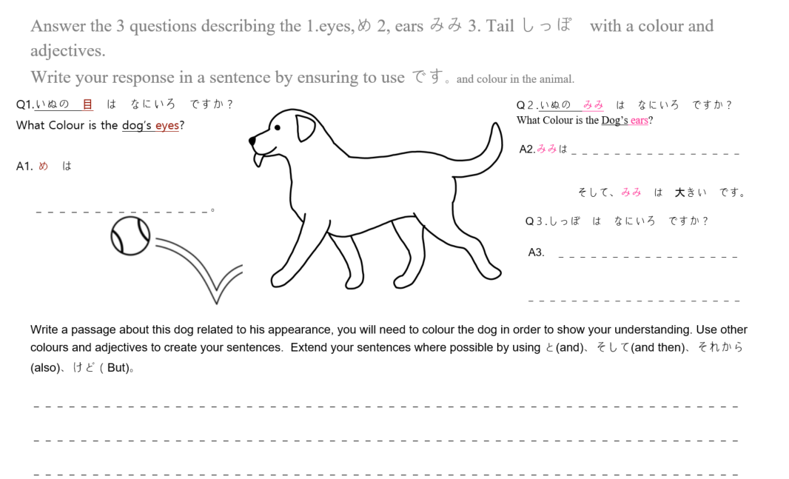
Completed worksheet

Interpreting evidence of student learning
Evidence collected from each student was mapped against the rubric:
- The quality criteria that were achieved was shaded in blue.
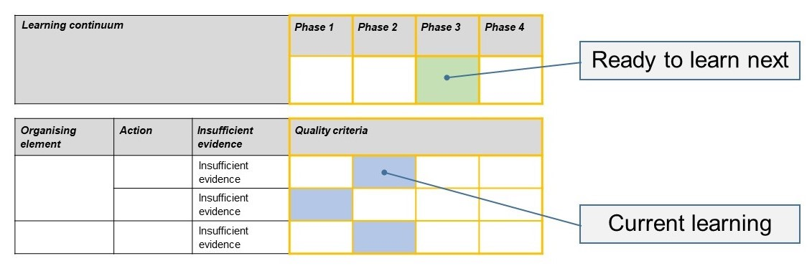
- The phase that the student is ready to learn next was shaded in green.

Please note, the following annotated student work samples are representative examples only.

Setting the scene
The formative assessment task was implemented a Grade 5 and 6 class in metropolitan Melbourne. The class was made up of students with varying abilities, with a diverse range of literacy skills and some learning difficulties.
The formative assessment task was implemented after students created a ‘Who is it?’ book. This book was used to describe various body parts using colours and other adjectives.
Students were given 20 minutes to complete the task, with about 5 minutes to describe the picture.
During the class, the teacher and students went through how to create a basic sentence and how to answer the first question. Students used a Quizlet page, where keywords were given to help them write in Japanese.
After the task, the students would be moving on to learn about foods and obento and working on how to describe both.

Sample 1

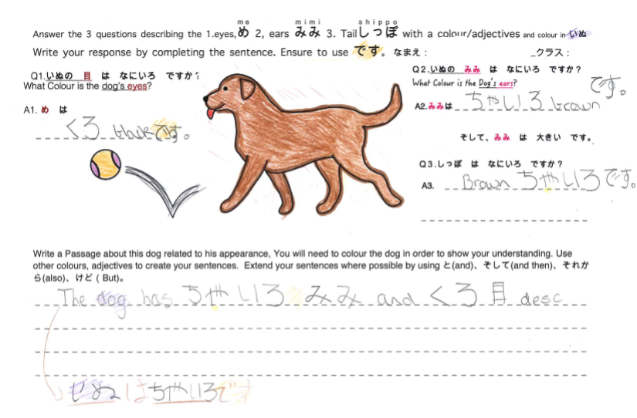
Sample 1: Evidence of student learning

Annotations
- The student has written a simple sentence and, with guidance, tried to write a basic sentence but has not written a full basic sentence by herself. (1.1)
- The student wrote in total four vocabulary words, using the same keywords frequently. (3.2)
- The information written correlates to the picture provided. (4.2)
- The student has written words in hiragana, with one kanji, but with a minor error. (5.2)
- This student was guided to help her complete her sentence on her worksheet because she kept forgetting to complete her sentence.
Insufficient evidence:
- Action 2 was assessed as ‘Insufficient evidence’ even though the student attempted answering the open-ended question. The student tried writing information about the dog but has not shown understanding of writing sentences correctly. She requires more help to understand an accurate sentence structure.

What is the student ready to learn next?
The student was assessed as ready to learn Phase 3 next. We can see that this student understands colours and how to write them in Japanese but she will need to work on completing full basic sentences.
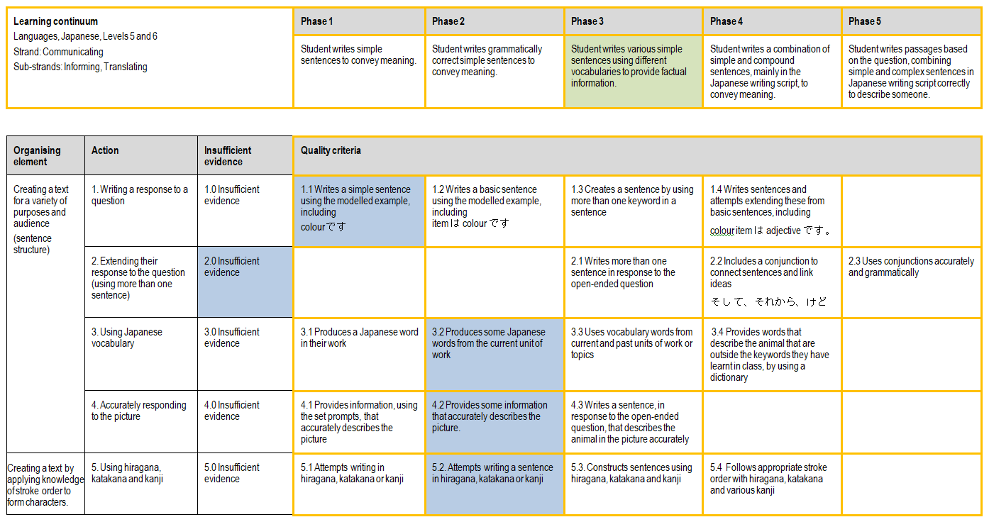

Any feedback given
The student was given feedback on her work and using colour coding understood what she need to complete the task.

Sample 2

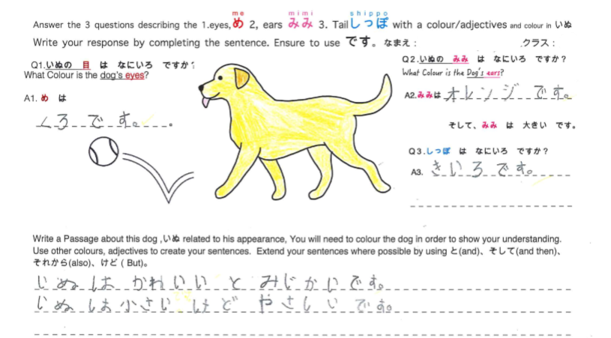
Sample 2: Evidence of student learning

Annotations
- The student has understood how to write sentences in Japanese and how to give more than one piece of information about a topic (1.3). The student has attempted to extend her description of the dog by linking two adjectives “cute” and “short”. Students at this level have not yet been taught how to modify the suffix of adjectives and descriptive nouns in order to do this correctly, so the student has simply attempted to convey her intended meaning by using the word “and” と.”
- The student has attempted to use the conjunction word ‘but’ けど in the middle of the sentence, but her ideas do not link in a logical way (2.2).
- The student has used various grammatical items, such as adjectives and colours (3.3).
- The student has provided various information about the dog. (4.3)
- The students has written hiragana, katakana and a kanji, and she has also written き but the lower stroke is detached, so it is different from the example き (5.3)

What is the student ready to learn next?
The student was assessed as ready to learn Phase 4 next. We can see that this student can most likely describe items in Japanese. She will work on how to extend her sentences and use other keywords to help her stay engaged in Japanese.
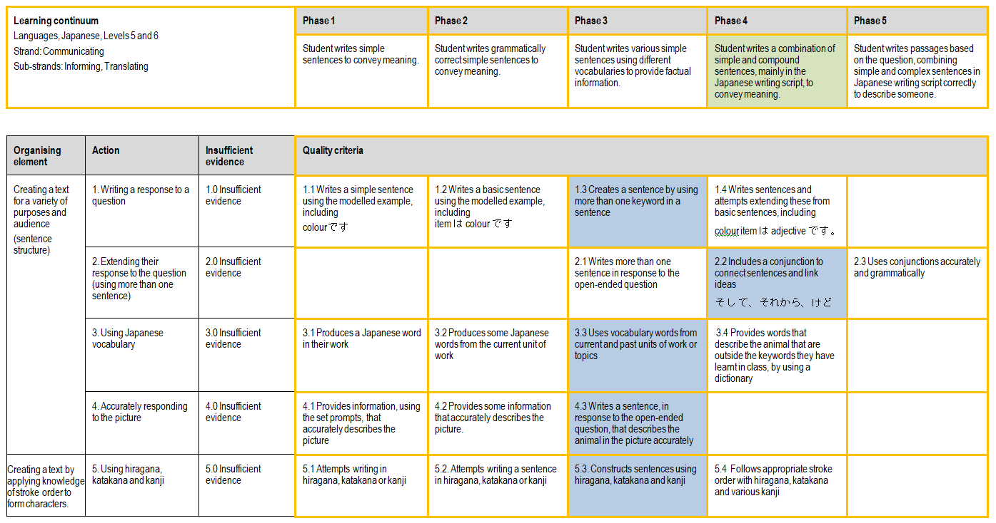

Any feedback given
This student was not given feedback during the task but she was encouraged to try to finish her sentence using conjunction words.

Sample 3

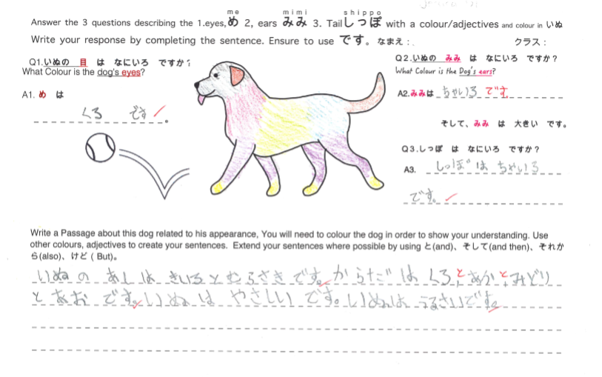

Sample 3: Evidence of student learning

Annotations
- The student has understood how to write sentences in Japanese and how to give more than one piece of information about a topic. (1.3)
- The student was able to provide in writing different information about the dog but has not used any conjunction words such as ‘but’ and ‘as well as’. (2.1)
- The student has used a variety of vocabulary, such as words for body parts and adjectives such as colours. (3.3)
- The student has provided various information about the dog. (4.3)
- The student has written hiragana but has not used any katakana or kanji (5.2).

What is the student ready to learn next?
The student was assessed as ready to learn Phase 4 next. We can work with her on using more kanji when required, and expanding her sentences and using some conjunction words to improve her skills in Japanese.
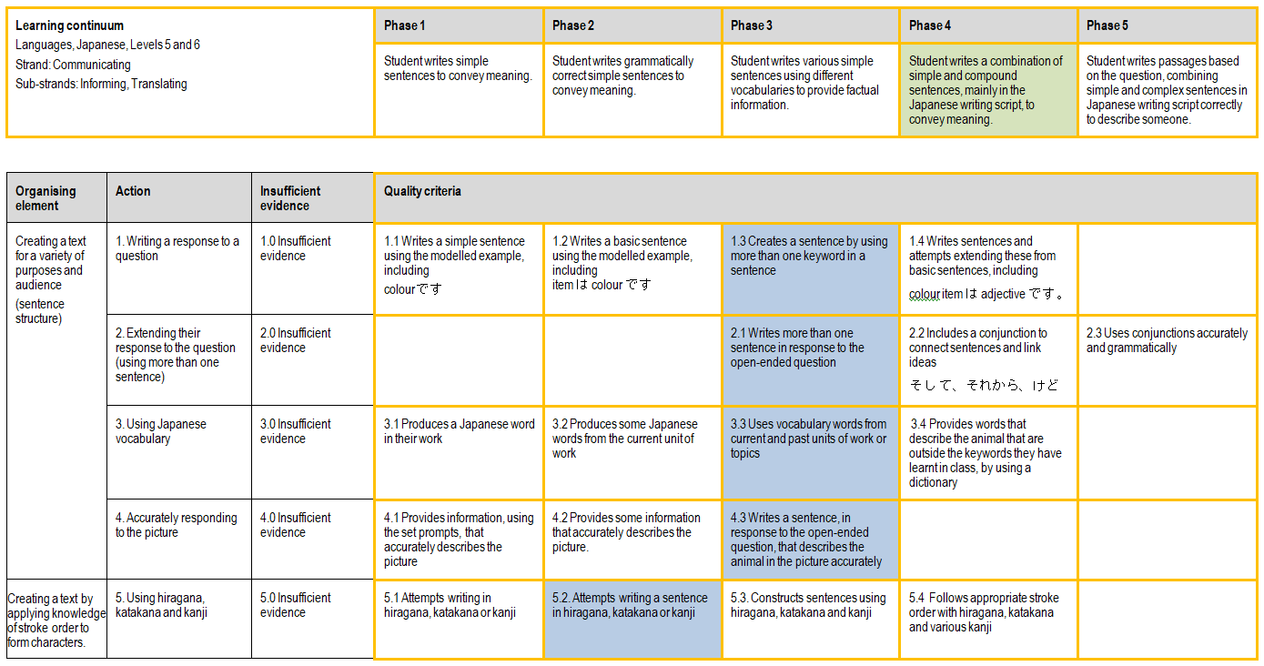

Any feedback given
The student has written sentences in Japanese. The student was advised to add the conjunction word ‘and’ between pieces of information, rather than just using a comma.

Using evidence to plan for future teaching and learning
Overall the students were able meet the first criterion of the actions. Some students showed insufficient evidence for action 2, which may be due to insufficient understanding of how to use conjunction words due to focusing more on simple and basic sentence.
In the future, I would use this task and rubric to help students reduce using romaji, improve their recognition in hiragana and improve their understanding of basic grammar and vocabulary. This task and rubric could be used again, possibly as a summative task or just before doing summative assessment.

Teacher reflections
I am happy with the final rubric, and the rubric and worksheet could be used by other teachers.
Some students struggled to read the detailed instructions on the worksheet, so I would consider simplifying the instructions next time
This formative assessment task would be hard to use in other curriculum area but perhaps by changing keywords it could be used for literacy in lower year levels.

