Levels 7 and 8: Historical Sources as Evidence – Student Handout

Activity: What can you learn about the Spanish conquest of the Americas from these sources of historical evidence?
Examine each of the historical sources below:
Source 1:
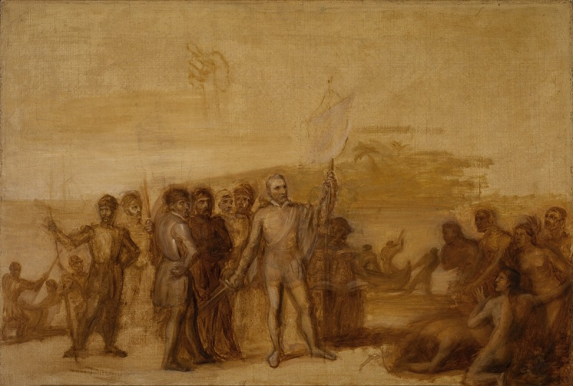
Caption: An oil sketch for the Landing of Columbus in the Rotunda of the United States Capitol by John Vanderlyn, c. 1842. This painting shows the moment, on 12 October 1492, when Columbus and his men landed on the island of San Salvador and claimed all of the New World for Spain. John Vanderlyn spent a great deal of time working on this piece and even travelled to the West Indies to make sure every detail of his painting was accurate.
Held in Smithsonian American Art Museum, Gift of I. Austin Kelly III.

Source 2:
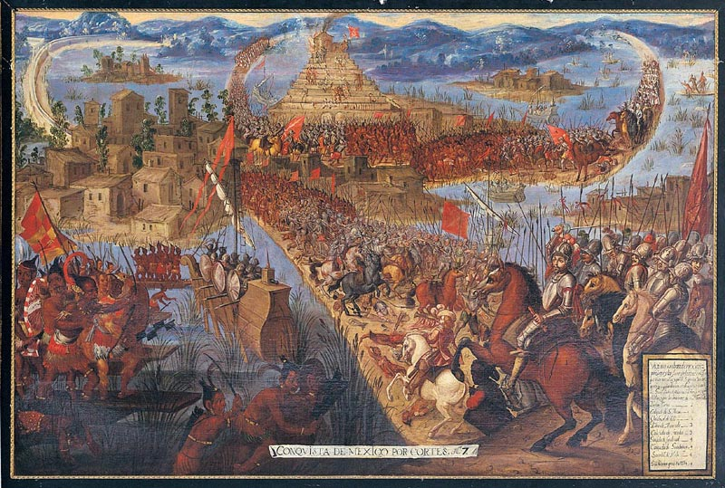
Caption: The Conquest of Tenochtitlan, from the Conquest of Mexico series, late 17th century; unknown artist. This painting is an attempt to show the excitement, bloodshed and drama of the extended siege (May to August 1521) in a single moment. Cortés can be seen leading his Spanish armies across one of the causeways and into the city. The captains of the other parts of his army also lead their troops towards the centre of the city and the main temple compound.
Jay I. Kislak Collection, Rare Book and Special Collections Division, Library of Congress.

Source 3:
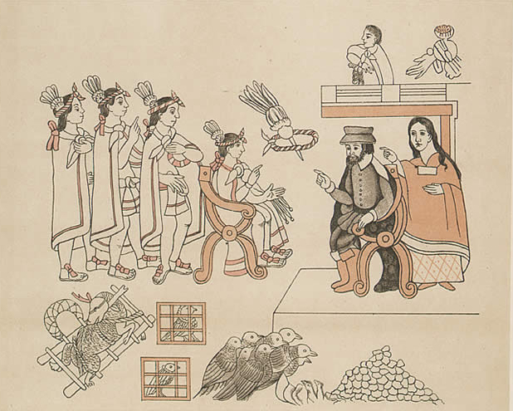
Caption: This is from the ‘Lienzo de Tlaxcala’, created by the Tlaxcalans in 1550 AD, to remind the Spanish of their loyalty to Castile and the importance of Tlaxcala during the Conquest. The text mixes European and native styles and includes anachronisms, such as the European-style chairs included in this image.
Held in the Bancroft Library.
Source 4:
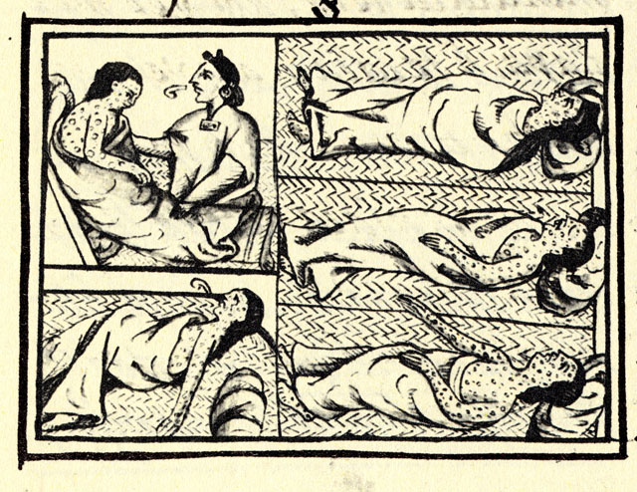
Caption: Smallpox depicted in Book XII on the conquest of Mexico in the Florentine Codex. The Florentine Codex is a 16th century compendium of materials and information on Aztec and Nahua history by Franciscan Friar Bernadino de Sahagun. Reproduction from the MS.
Held at Biblioteca Medicea Laurenziana, Florence.
Source 5:
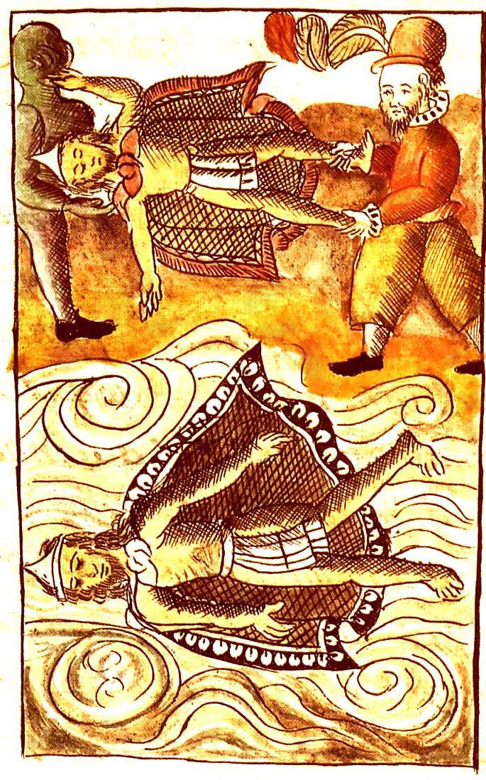
Caption: Spaniards disposing of the bodies of Moctezuma II (emperor of the Aztecs) and Itzquauhtzin (King of the Nahua) in the Florentine Codex. The Florentine Codex is a 16th century compendium of materials and information on Aztec and Nahua history by Franciscan Friar Bernadino de Sahagun.
Reproduction from the MS held at Biblioteca Medicea Laurenziana, Florence.
- For each source, complete the table below:

Creator of the source:
Date created:
Title and/or subject:
Location:
Type of Source: written, visual, audio
Is it a primary or secondary source? Explain why.
Whose perspective of the event(s) depicted is shown in the source? Give evidence for your answer.
What was the intent of the creator of the source? Why do you think this?

- How accurate is each source? Use the table to below to rank the sources from most accurate to least accurate and explain your choices.

Rank | Source | Explanation for ranking

- How useful is each source? Use the table to below to rank the sources from most useful to least useful and explain your choices.

Rank | Source | Explanation for ranking

- How reliable is each source? Use the table to below to rank the sources from most accurate to least accurate and explain your choices.

Rank | Source | Explanation for ranking

- Using the sources, list three to five important things you can learn about this time from each one. Some aspects to consider include:
- What is happening?
- How are figures positioned? (e.g. in the foreground? in the background?)
- Who is included?

- Choose one of the sources and annotate it with your answers to Question 1.

