Levels 9 and 10: Historical Sources as Evidence – Teacher Notes

Activity: Evaluating and comparing historical sources
The concept maps provided in the activity can be printed on A3 and pinned to the centre of the whiteboard (or shown digitally in the centre of a shared screen) so that you and the students can organise your ideas around it.
Source A: Written
‘War’ by Mary Gilmore
Students’ answers will vary, but their research should consider the following:
- Mary Gilmore’s only son was around sixteen years of age when World War I broke out.
- The poem was published in 1932, but it is not clear when the poem was actually written.
- Gilmore wrote other war poems such as ‘Gallipoli’ (1918) and ‘No foe shall gather our harvest’ (1940).
Source B: Visual
World War I poster
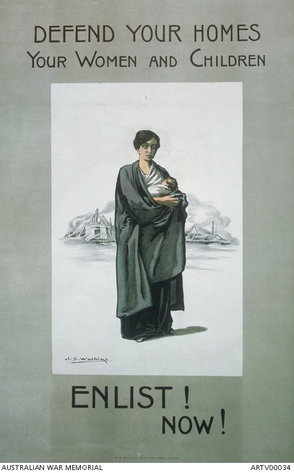

Australian First World War recruitment poster; made by John Samuel Watkins for the NSW Government; printed by W.A. Gullick, Government Printers,
c. 1916–1918

Students’ answers will vary, but their research should consider the following:
- Many of these posters were created by the federal and state governments during World War I.
- Service in the military forces was voluntary in Australia throughout World War I.
- Many Australian soldiers were injured and killed during the war and needed to be replaced.

