Mathematics: Learning Area Leader Guide
Implementing the Victorian Curriculum F–10 Version 2.0 Mathematics

Authorised and published by the Victorian Curriculum and Assessment Authority
Level 7, 2 Lonsdale Street
Melbourne VIC 3000
© Victorian Curriculum and Assessment Authority 2023

No part of this publication may be reproduced except as specified under the Copyright Act 1968 or by permission from the VCAA. Excepting third-party elements, schools may use this resource in accordance with the VCAA educational allowance. For more information go to https://www.vcaa.vic.edu.au/Footer/Pages/Copyright.aspx.
The VCAA provides the only official, up-to-date versions of VCAA publications. Details of updates can be found on the VCAA website at www.vcaa.vic.edu.au.
This publication may contain copyright material belonging to a third party. Every effort has been made to contact all copyright owners. If you believe that material in this publication is an infringement of your copyright, please email the Copyright Officer vcaa.copyright@edumail.vic.gov.au
Copyright in materials appearing at any sites linked to this document rests with the copyright owner/s of those materials, subject to the Copyright Act. The VCAA recommends you refer to copyright statements at linked sites before using such materials.
The VCAA logo is a registered trademark of the Victorian Curriculum and Assessment Authority.

Contact us if you need this information in an accessible format - for example, large print or audio.
Telephone (03) 9032 1635 or email vcaa.media.publications@edumail.vic.gov.au

Contents
About this guide 1
Introduction 1
Timeline 2
Levels F–10: Curriculum revisions 2
High level overview of Levels F–10 revisions 2
Prepare for implementation 3
Familiarise yourself and your team with the curriculum 3
Analyse current teaching and learning units 6
Consider pathways to VCE Mathematics studies 7
Plan for curriculum implementation 8
VCAA curriculum planning resources 8
VCAA curriculum planning resources for Mathematics Version 2.0 10
Additional VCAA resources for Mathematics Version 2.0 10
Using the VCAA resources and templates 10

About this guide
This Mathematics: Learning Area Leader Guide provides information about the key revisions between the Victorian Curriculum F–10 Version 1.0 Mathematics (Mathematics Version 1.0) and the Victorian Curriculum F–10 Version 2.0 Mathematics (Mathematics Version 2.0).
It outlines the VCAA curriculum planning documents that are available and how they can be used to support the process of updating a school’s current curriculum documentation.
Note, the term ‘unit’ is used throughout the VCAA curriculum planning documents to refer to a Mathematics topic being studied, for example, ‘Counting with fractions’ or ‘Two-dimensional representations’.

Introduction
The Mathematics Version 2.0 curriculum is based on findings and recommendations from some of Victoria’s educational leaders and experts and Mathematics specialists and teachers. It reflects feedback from the VCAA’s formal monitoring conducted over the past 5 years; the significant consultation conducted by the Australian Curriculum, Assessment and Reporting Authority (ACARA) in reviewing the Australian Curriculum Foundation to Year 10; and advice provided by members of the VCAA’s Curriculum Area Reference Panels.
It offers a simple and manageable structure that:
- embeds the proficiencies in the content descriptions and achievement standards
- organises content under 6 strands – Number, Algebra, Measurement, Space, Statistics and Probability (from Level 3) – with no sub-strands
- increases scope to make connections across the Mathematics curriculum
- includes clearer content descriptions and better-aligned achievement standards
- provides improved sequencing of concepts, with stronger links across strands
- provides enhanced clarity through:
- level descriptions that outline in greater detail the content, skills and expected outcomes at each level
- content descriptions with clearer articulation of the essential mathematical facts, procedures and skill
- elaborations with more examples
- has stronger alignment with the Victorian Early Years Learning and Development Framework (VEYLDF) and senior secondary pathways, which creates a continuum of learning from birth to 18-plus.
Mathematics Version 2.0 is currently available on the Victorian Curriculum F–10 website. In 2024, the curriculum will be transferred to a new website offering increased functionality.

Timeline
Mathematics Version 2.0 will have a phased familiarisation and implementation across 2023–2025 as follows:
 | 2023 |  | 2024 | 2025
Mathematics |  | Familiarisation | Familiarisation | Full Implementation
 |  |  | Start Implementation
Government and Catholic schools can implement the revised curriculum from 2024, with full implementation in 2025. Implementation in independent schools is at the discretion of each school in the sector.

Levels F–10: Curriculum revisions
This section outlines high level whole-of-curriculum revisions for Mathematics Version 2.0 Foundation to Level 10 and provides an overview of the key revisions for each individual level.

High level overview of Levels F–10 revisions
- The 4 proficiencies of Understanding, Fluency, Reasoning and Problem-solving have been embedded in the content descriptions and achievement standards, which now more clearly articulate the proficiencies.
- There is greater emphasis on the processes of mathematical modelling, statistical investigation, probability simulations and estimation while retaining key foundational knowledge and skills as students approach senior secondary pathways.
- There are enhanced opportunities for students to connect to real-world experiences.

Levels F–6 revision
- Content has been resequenced to provide students with opportunity to consolidate and master key skills.
- There is increased prominence for computational and algorithmic thinking.
- Play- and exploration-based content is included across Foundation to Level 2.
- Main content shifts:
- Probability commences at Level 3
- Level 2: Recognise and describe one-half as one of two equal parts of a whole, and tell time to the half-hour, have shifted from Level 1 to Level 2
- Level 2: Comparing volumes of objects informally beyond capacity is no longer part of Level 2
- Level 5: The formal calculation of volume is now introduced at Level 7
- Level 6: Connection between volume and capacity has shifted to Level 8
- Level 6: Associative, commutative and distributive laws are now introduced at Level 6

Levels 7–10 revision
- There is continued focus on computational and algorithmic thinking, including provision for pseudocode to support teachers who do not have background familiarity with simple coding languages.
- A small number of new content descriptions that extend the scope of learning have been added:
- Level 8: inclusion of 3-dimensional mapping
- Level 10: inclusion of planar graphs (networks)
- Level 10: inclusion of logarithmic scales (not equations or laws).
- Main content shifts:
- Level 8: Solving one variable inequalities, connecting volume and capacity and their units of measurement are now introduced at Level 8 (previously at Level 6), and introduction of Pythagoras’ theorem
- Level 10: Inclusion of the use of simulation with digital tools to model conditional probability

Level 10A
Level 10A continues to provide students and teachers with a set of content that is cognitively positioned between Level 10 and Units 1 and 2 VCE. Level 10A is:
- designed to complement Level 10 content
- not a standalone level (there is no additional achievement standard)
- not required content for access to any of the VCE Mathematics suite of studies.

Prepare for implementation

Familiarise yourself and your team with the curriculum
Familiarisation with the revised curriculum is a collaborative process that is coordinated by the Mathematics Learning Area Leader or Numeracy Leader. Familiarity with Mathematics Version 2.0 can be progressively developed and refined through a program of planned learning area and year level team meetings and discussions. This should be complemented by VCAA professional learning, a targeted school-based program of professional learning, and the reading of key VCAA documents.
The following are some activities that can be undertaken with school Mathematics teachers and year level teams to facilitate the familiarisation process.

Related documents
Related VCAA content and documents can be found on the Victorian Curriculum F–10 website and the VCAA website, including:
- Victorian Curriculum F–10 Mathematics Version 2.0
- Introducing Mathematics Version 2.0
- Mathematics – comparison of curriculums document (Version 1.0 to Version 2.0)
- Mathematics Version 2.0 scope and sequence documents by strand, from Foundation to Level 10A
- Mathematics Version 2.0 – transitional advice (for first year of implementation only)

Activity 1: Explore the Mathematics Version 2.0 aims
The rationale and aims in the introduction section of Mathematics Version 2.0 provide the basis for the construction of the curriculum and an understanding of why it is being studied by all students across Prep to Year 10.
- Discuss each of the aims of the curriculum (see below) and explore how they relate to the content covered in Foundation to Level 10, focusing on the levels appropriate to your school context.
- Discuss what learning looks like when your students are demonstrating the aims at a particular level.
Note, the aims relate to cognitive and affective outcomes.

Aims
Mathematics aims to ensure that students:
- develop useful mathematical and numeracy skills for everyday life and work, as active and critical citizens in a technological world
- become confident, proficient, effective and adaptive users of mathematics
- become effective communicators of mathematics who can investigate, represent and interpret situations in their personal and work lives, think critically, and make choices as active, engaged, numerate citizens
- develop proficiency with mathematical concepts, skills, procedures and processes, and use them to demonstrate mastery in mathematics as they pose and solve problems, and reason with number, algebra, measurement, space, statistics and probability
- make connections between areas of mathematics and apply mathematics to model situations in various fields and disciplines
- develop a positive disposition towards mathematics, recognising it as an accessible and useful discipline to study
- appreciate mathematics as a discipline – its history, ideas, problems and applications, aesthetics and philosophy.

Activity 2: Understand the structure of the revised Mathematics curriculum
- Refer to the Victorian Curriculum F–10 Version 2.0 Mathematics.
- In small groups, identify and discuss how the proficiencies have been incorporated in the content descriptions and achievement standards of the revised curriculum.
- Consider and discuss how the structural change to 6 strands provides further opportunity for connections between strands.
- Take a closer look at the revised curriculum content for the year levels you will be teaching, identify any key revisions and consider what opportunities, if any, they will offer for unit composition and sequencing, strengthening connections between and across concepts, teaching approaches, the use of digital tools and assessment.

Activity 3: Explore the mathematical processes and their role in the curriculum
- Refer to the Learning in Mathematics Version 2.0 section of the curriculum to review the 4 processes.
- Identify the 4 processes of mathematical modelling, computational thinking and simulations, statistical investigations, and probability experiments and simulations and discuss how they provide a new focus in the revised curriculum.
- Use the scope and sequence documents to see the progressive development of the 4 processes across levels and strands.
- How can the 4 processes be addressed within the year levels you teach?
- What digital tools could be used to support the development of these processes, and how might they be used?
- Identify where the processes are addressed in the achievement standards and how they might be assessed.
- The following diagram is a common representation of the modelling or problem-solving cycle. How could this representation be adapted for the other 3 processes?
Figure 1: Modelling or problem-solving cycle
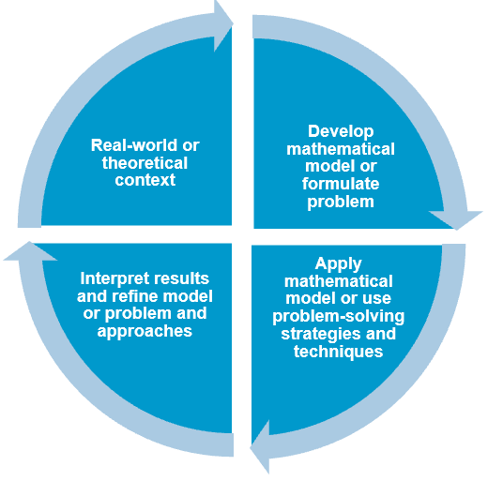

Activity 4: Compare the curriculums (Version 1.0 to Version 2.0)
- Use the VCAA comparison of curriculums document (Version 1.0 to Version 2.0) to identify key revisions, for example change of level for a content description or a new content description.
- Discuss the enablers and challenges to how the curriculum can be sequenced within and across levels and strands.
- Highlight the content descriptions that have been moved down levels (e.g. from Level 3 in Version 1.0 to Level 2 in Version 2.0). Refer to the transitional advice document. Discuss why it is important that this content is covered at both levels in the year of implementation.

Analyse current teaching and learning units
The following steps have been developed to support Mathematics Learning Area Leaders or Numeracy Leaders working with teaching teams to develop a Mathematics school-based curriculum for Levels F–10 of the revised curriculum that is appropriate to their school context.

Related documents
- Victorian Curriculum F–10 Mathematics Version 2.0
- Mathematics – comparison of curriculums document (Version 1.0 to Version 2.0)
- Mathematics Version 2.0 scope and sequence documents by strand, from Foundation to Level 10A
- your school’s current Mathematics curriculum documentation

Step 1: Identify curriculum level changes from Version 1.0 to Version 2.0
This step is designed to be carried out in year level teaching teams and requires access to copies of the school’s current set of teaching and learning units for the level being reviewed.
- Review the relevant level of the VCAA comparison of curriculums document to identify any key changes and shifts for the curriculum level. Mark up the school’s current teaching and learning units as follows:
- Highlight any removed content descriptions in red.
- Highlight key revisions in orange and include an annotation detailing the revision.
A key revision could be content descriptions that have been realigned from one level to another or content descriptions whose scope has been revised significantly.
- Add in any new content descriptions that are relevant to the specific teaching and learning unit and highlight in green. Alternatively, indicate the inclusion of new content description with a green asterisk and include an annotation.

Step 2: Consider the implications for teaching and learning units
Once the content for the teaching and learning units has been reviewed, consider and discuss any implications the identified revisions have on each unit, for example:
- Are there other content descriptions that would fit well within this unit or some that might be better addressed within a different unit?
- Are there implications in relation to the prior knowledge students will need?
- Does the duration of this unit need to be reviewed?

Step 3: Develop a related assessment plan
- Similar to your work in Steps 1 and 2, review any changes to the achievement standard(s) and update the focus achievement standard extracts in your teaching and learning units where relevant.
- Review the existing assessment tasks with respect to their suitability for the teaching and learning units.
- For each teaching and learning unit, identify opportunities for formative and summative assessment, considering the possible nature of the task (for example, test, assignment, modelling or problem-solving task, project or investigation, oral presentation or report) and its duration and timing.

Step 4: Revise or reconfigure the teaching and learning units
Once this analysis has been carried out, the year level team and the Mathematics Learning Area Leader or Numeracy Leader should consider each teaching and learning unit and decide: Is it best to revise the current teaching and learning unit or to reconfigure it afresh?
Revise and reconfigure the current teaching and learning units as needed.

Step 5: Sequence the teaching and learning units
- Look at your current sequence of units across the level.
- How might the findings or considerations from Steps 1–4 inform the sequence of units?
- How might the decoupling of the strands provide opportunities within the units?
- What might be some of the benefits and limitations of a particular sequence of units compared to another possible sequence?
The VCAA Mathematics: Teacher Guide provides advice on how to use VCAA resources to develop teaching and learning units.

Consider pathways to VCE Mathematics studies
The Level 10 curriculum provides the basis for students to proceed to any of the VCE Mathematics Units 1 and 2 studies. Level 10A provides additional content that complements the Level 10 content and provides opportunity for further breadth and/or depth in the development of mathematical concepts, skills and processes.
Discuss which Level 10A content might be useful to support pathways to the various VCE Mathematics Units 1 and 2 studies, or combinations of those studies.

Plan for curriculum implementation
The VCAA has developed a suite of curriculum planning templates and examples to support schools with implementing the revised Victorian Curriculum F–10. It has also produced completed examples for Mathematics Version 2.0 and additional support materials for Mathematics Version 2.0.

VCAA curriculum planning resources
The table below outlines the key elements in the VCAA curriculum planning resources. It is followed by a diagram that illustrates the relationships between them.
Curriculum planning element | Format(s) | Audience(s)
Whole-school curriculum plan  A curriculum implementation plan for an individual school. Covers each learning area and discipline (along with the capabilities and cross-curriculum priorities). | - Templates  - Completed examples  Note: These will be published after the entire Version 2.0 curriculum has been published. | School Curriculum Leaders
Year level plan  A subset of the whole-school curriculum plan. Covers the curriculum implementation of each learning area and discipline by individual year levels. | - Templates  - Completed examples  Note: These will be published after the entire Version 2.0 curriculum has been published. | Year Level Coordinators
Curriculum area plan  A primary, secondary or whole-school (P–10) plan for a single curriculum area. Offers a snapshot of the topics or teaching and learning units across Semester 1 and Semester 2. | - Template  - Completed examples | Learning Area Leaders
Curriculum area map  Identifies where the content descriptions and achievement standards are explicitly addressed in the teaching and learning units for a year level. | - Templates (one per curriculum level or band)  - Completed examples | Learning Area Leaders
Teaching and learning unit  Provides a guide to the delivery of a series of lessons on a topic or theme that maps to content descriptions and achievement standards, including cohort considerations and a detailed lesson sequence. | - Template  - Completed examples | Learning Area Leaders  Year Level Teachers
Lesson plan  Expands on the information provided in a teaching and learning unit. Includes curriculum-aligned learning goals/intentions, the content to be addressed, and the pedagogical approaches, activities and resources to be used for a classroom session. | Not supplied by the VCAA | Year Level Teachers

In the following diagram, the cells shaded in orange highlight the documentation that Learning Area Leaders complete. The cells outlined with an orange border highlight the documentation that Learning Area Leaders refer to when completing them.
A whole-school curriculum plan should be referred to after the entire Version 2.0 curriculum has been published.
Figure 2: Curriculum planning architecture – Learning Area Leaders
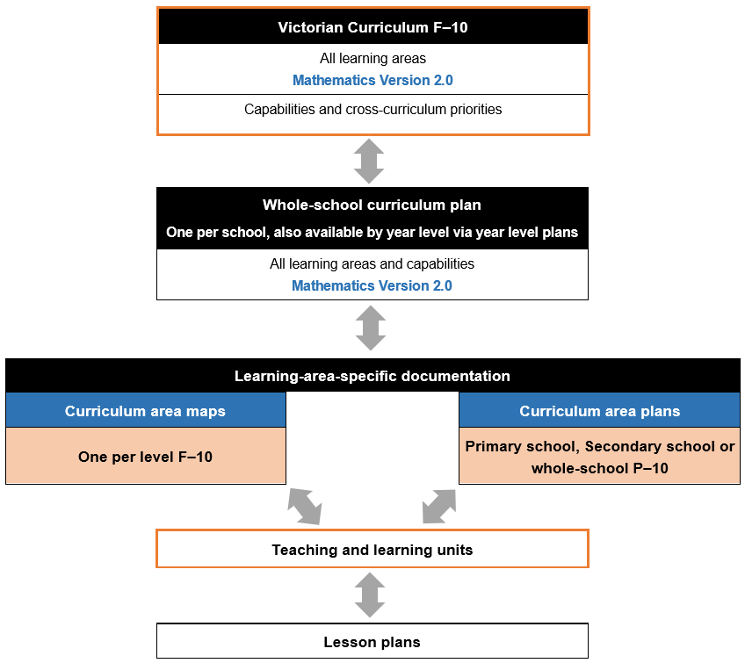

VCAA curriculum planning resources for Mathematics Version 2.0
The following resources are available to support curriculum planning for Mathematics Version 2.0:
- example curriculum area plans for P–6 and 7–10, plus a template
- example curriculum area maps for Level 3 and Level 8, plus templates for each level that include Version 2.0 curriculum content
- example teaching and learning units for Level 3 and Level 8, plus a template.

Additional VCAA resources for Mathematics Version 2.0
The following additional resources are available to support planning for the implementation of Mathematics Version 2.0:
- 2 exemplar VCAA assessment tasks addressing specific aspects of the revised achievement standards for Level 3 and Level 8
- Mathematics glossary
- Introducing Mathematics Version 2.0
- Mathematics – comparison of curriculums document (Version 1.0 to Version 2.0)
- Mathematics Version 2.0 scope and sequence documents by strand, from Foundation to Level 10A
- Mathematics Version 2.0 – transitional advice (for first year of implementation only).

Using the VCAA resources and templates

Create a curriculum area map
A curriculum area map template can be used to illustrate where the content descriptions and achievement standards are explicitly addressed within the teaching and learning units planned for a year level. A completed curriculum area map lists the associated common assessment activities and tasks for each unit and can assist leaders to sequence units across the year so there is progressive development of key mathematical concepts, knowledge and skills.
Curriculum area maps are one of the key curriculum planning elements. They support the completion of a curriculum area plan (for the focus curriculum area), as well as year level plans and whole-school curriculum plans (for all curriculum areas).
Figure 3: Curriculum area maps as a key curriculum planning element

Related documents
The following VCAA documents can be drawn on when developing a curriculum area map for Mathematics Version 2.0:
- the relevant curriculum area map template (e.g. Mathematics Level 5 map)
- Victorian Curriculum F–10 Mathematics Version 2.0
- Mathematics – comparison of curriculums document (Version 1.0 to Version 2.0)
- Mathematics Version 2.0 scope and sequence documents by strand, from Foundation to Level 10A
- an example VCAA curriculum area map for Level 3 or Level 8
- an example VCAA teaching and learning unit for Level 3 or Level 8
- the curriculum area plan template
- glossary.

Steps, considerations and actions
The consideration and actions for each of the following steps should be informed by feedback from the teaching and learning unit analysis undertaken in Steps 1–5 of the ‘Plan for curriculum implementation’ section.
Step | Considerations and actions
1 | Review the content descriptions, elaborations and associated achievement standards in the Victorian Curriculum F–10 Mathematics Version 2.0 to gain a measure of the breadth and depth of content to be covered.  Familiarise yourself with the content descriptions and achievement standards for the levels before and after the one you are focusing on. Refer to the scope and sequence to see the related developmental progression across levels.  Use the comparison of curriculums document to familiarise yourself with any revisions that are applicable to this level.
2 | Review the achievement standard extract(s) for each unit and determine the common formative and summative assessment activities and tasks to be completed.
3 | Consider the following questions before allocating content descriptions to units:  What are some of the natural mathematical connections between content descriptions in a strand and between strands?  Are there specific cohort needs to be considered?  What relevant student data is available to refer to?  Finalise the mathematical focus and names of each unit.  Refer to the example VCAA curriculum area map for Level 3 or Level 8 and the example VCAA teaching and learning unit for Level 3 or Level 8 if applicable.
4 | Connect the allocated content description(s) with the corresponding achievement standard extract(s).
5 | Establish the sequence of units, giving thought to:  - What prior knowledge will students need for each unit?  - How might key concepts be consolidated and extended on over the course of the year?  - What might be some of the benefits and limitations of a particular sequence of units compared to another possible sequence?  Refer to the glossary as applicable.
6 | Begin completing the relevant curriculum area map template, based on the considerations from Steps 1–5.  - Fill in the title of each teaching and learning unit in the first column of each mapping table and the semester it is to be completed in.  - Indicate the connections to the curriculum by checking the box of the relevant content description(s) and writing the number of the relevant extract(s) from the achievement standard.  Where a unit addresses more than one strand, it should be listed in the first column of each strand mapping table.  Include any specific comments at the bottom of each strand mapping table as required.
7 | Audit your curriculum area map to check that each content description and achievement standard extract has been covered.
8 | Complete the Assessment section towards the end of the document.  List the units in order, including the associated assessment activities and tasks, and the achievement standard extract number(s) covered by each unit.  Each achievement standard extract number should appear at least once in this table.
9 | Complete the Analysis of Curriculum Coverage section towards the end of the document.  Have all the content descriptions and achievement standards been covered?  If not, provide details on how they will be addressed elsewhere.  Outline the allocated time per semester and any content that may need additional time.
10 | Complete the Next Steps section at the end of the document, commenting on any general considerations that Year Level Teachers should note or action.  List any specific items to consider when populating or updating your curriculum area plan.

The diagram below connects each section of the template with the corresponding step.
Figure 4: Curriculum area map template and corresponding steps
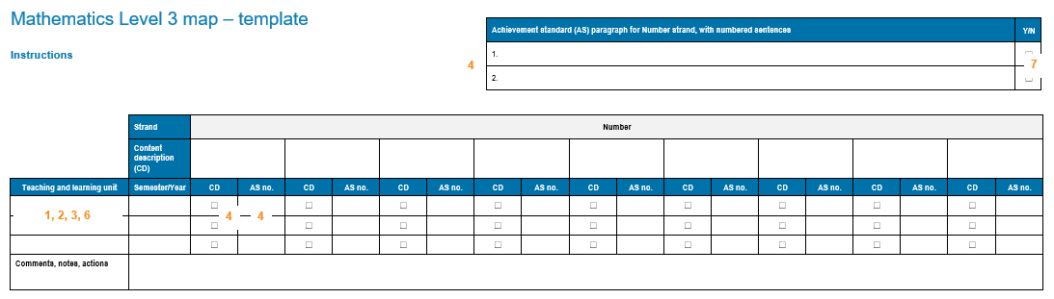
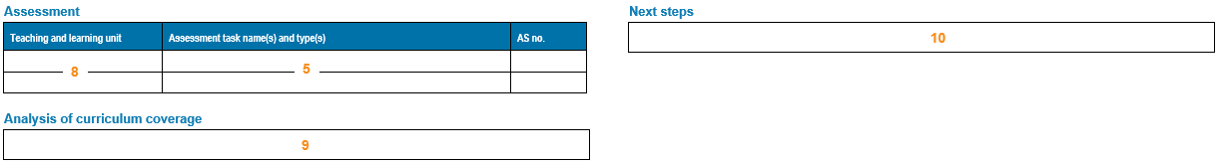

Create a curriculum area plan
A curriculum area plan is a primary, secondary or whole-school (P–10) plan for a single curriculum area, offering a snapshot of the topics or teaching and learning units across Semester 1 and Semester 2. A Mathematics curriculum area plan includes the following information:
- unit focus, duration and location within Semesters 1 and 2
- the spread of strands within and across year levels.
The horizontal structure and display of this information provides Learning Area Leaders with the opportunity to assess the balance of units across the strands and the overall Mathematics learning progression.
A curriculum area plan requires a complete set of curriculum area maps before it can be filled out. These plans then support the completion of year-level and whole-school planning documentation that encompass all learning areas and disciplines.

Related documents
The following VCAA documents can be drawn on when developing a curriculum area plan for Mathematics Version 2.0:
- the curriculum area plan template
- Victorian Curriculum F–10 Mathematics Version 2.0
- your completed curriculum area maps
- school teaching and learning units.

Steps, considerations and actions
Step | Considerations and actions
1 | Select any completed curriculum area map level to start. The curriculum area plan template can be filled out in any level order.  Commence by filling in the Semester 1 unit titles in order across the top row for the year level, including the vertical dividers separating the units and indicating the approximate duration of each unit in weeks.
2 | Use the curriculum area map to complete the second row for Semester 1, indicating the strand(s) that each unit addresses.
3 | Repeat Steps 1 and 2 for Semester 2 and continue this process for the remaining year levels.
4 | Once the curriculum area plan is complete, assess your plan for balance within and across year levels:  How balanced is the distribution of strands?  Is a particular strand under- or over-represented?  How does the overall Mathematics learning progression flow? Are there any identifiable gaps or repetitions?  Refer to the Victorian Curriculum F–10 Version 2.0 Mathematics as applicable.
5 | Adjust the curriculum area plan as needed and make any corresponding adjustments to the curriculum area maps and teaching and learning units.
The following diagram connects each section of the curriculum area plan template with the corresponding step.
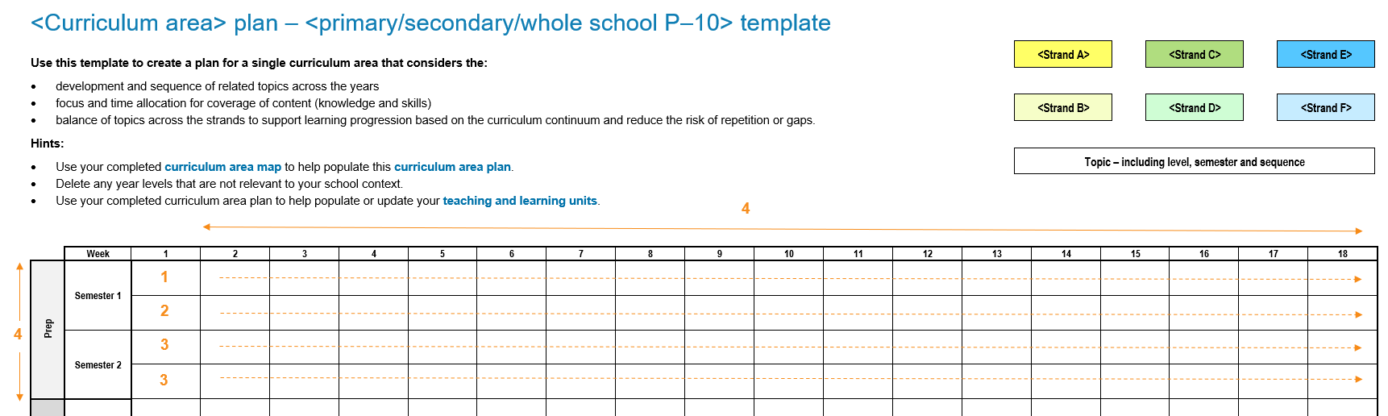
Figure 5: Curriculum area plan template and corresponding steps

