Respectful Relationships: Gender and Identity
Foundation Level

Topic: Gender and identity

Level: Foundation

Victorian Curriculum F-10

Personal and Social Capability

Content descriptions
Identify their likes and dislikes, needs and wants, abilities and strengths (VCPSCSE002)

Achievement Standard (extract only)

By the end of Foundation Level, students … recognise personal qualities and achievements by describing activities they enjoy at school and home, noting their strengths.

Health and Physical Education

Content descriptions
Identify personal strengths (VCHPEP057)

Achievement Standard (extract only)

By the end of Foundation Level, students recognise how they are … changing

Teaching and learning activities
The Department of Education and Training have developed Foundation Resilience, Rights and Respectful Relationships teaching and learning materials. The following teaching and learning activities are designed to teach the knowledge, skills and understandings relating to gender and identity for the Foundation Level. See pages 31 to 37.
Activity 1: Who am I? Different things to know about me
Activity 2: Exploring gender: Boys and girls can be the same and different
Activity 3: Anyone can choose
Activity 4: Everyone can be strong and gentle

Assessment ideas

Pre-assessment
Ask students to create a list of their likes and dislikes using a variety of pictures, for example dogs, cats, ice cream, spaghetti, playing football, skipping, reading and watching cartoons. Pictures can be collected from magazines or printed from the internet. Create a class graph with different things the class likes. Students add pictures of themselves to the relevant columns to make a shared graph. Use the graph to start the discussion with students about ‘Do girls and boys like the same things or different things?’
Refer to the assessment rubric on page 4 to identify where students are located on the Victorian Curriculum F-10 continuum.

Summative Assessment

Reflecting on similarities and differences
Assess students understanding of the concepts of ‘same’ and ‘different’, using the pictures that students produced of themselves in activity 1, part 2. Ask students to share their picture with the class and to identify something that is the same and something that is different from another class member. Ask students to reflect on similarities and differences between boys and girls by asking questions such as:
- Do all boys like the same things?
- Do all girls like the same things?
- Is it OK for girls and boys to like the same things?
- Is it OK to like different things from your friends?

Worksheet: Being strong and gentle
Give students the chart (see page 3) and ask them to draw or write a sentence, to show the boy and girl when they are gentle and strong. The purpose of this task is to assess students’ ability to understand that both boys and girls can be strong and gentle.
Refer to the assessment rubric on page 4 to identify where students are located on the Victorian Curriculum F-10 continuum.

Worksheet: Being strong and gentle
 | 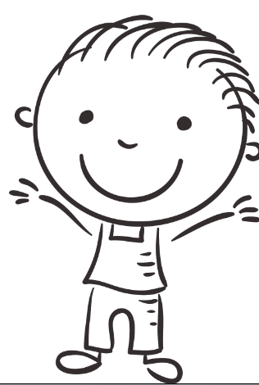 | 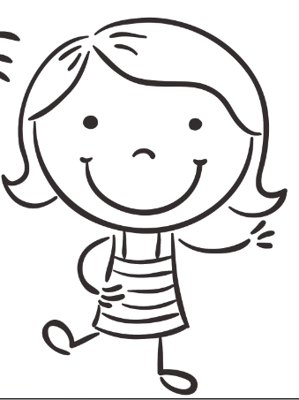
Strong
Gentle

 | Relevant element of the Achievement Standards
 |  | Foundation |  | Level 2
 | Personal and Social Capability
 |  | By the end of Foundation Level, students… recognise personal qualities and achievements by describing activities they enjoy at school and home, noting their strengths. |  | By the end of Level 2, students ... identify and describe personal interests, skills and achievements and reflect on how these might contribute to school or family life.
 | Health and Physical Education
 |  | By the end of Foundation Level, students recognise how they are … changing |  | By the end of Level 2, students… recognise how strengths and achievements contribute to identities.

Gender and identity assessment rubric – Foundation

 | Assessment Rubric
Category | Progressing towards Foundation students can: | At Foundation students can: | Progressing towards level 2 students can: | At level 2 students can:
Identification of personal likes and dislikes | - show some personal likes and dislikes | - list and describe personal likes and dislikes | - identify differences in personal likes and dislikes between themselves and others | - describe how personal interests contribute to school or family life
Understanding gender similarities and differences | - show through images/pictures some similarities and differences between girls and boys | - identify similarities and differences between girls and boys | - display some awareness that gender should not restrict what they like and are able to do | - recognise that gender should not restrict what they like and are able to do
Demonstration of appropriate times to be strong and gentle | - respond to a range of scenarios where it is appropriate to be strong or gentle | - provide an example of being strong and gentle for both boys and girls | - describe a situation when they have been strong and gentle at the same time | - recognise that being strong and gentle is not associated with being a boy or being a girl

