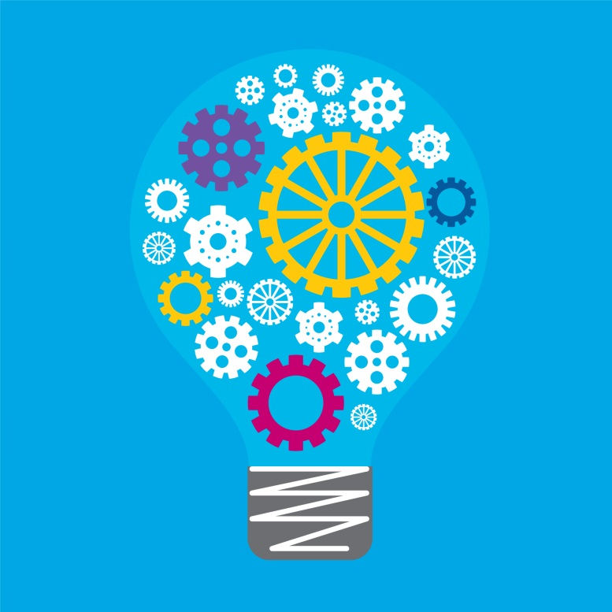
STEM
Unpacking the Content Descriptions
Levels 5–6

Unpacking the content descriptions – STEM
Levels 5 – 6
Integrating Science and Digital Technologies (STem)
Focus: Integration of content related to designing and using algorithms in simple electric circuits and/or devices utilising electricity as an energy source

Learning area | Science | Learning area | Digital Technologies
Strand | Science Understanding | Strand | Creating Digital Solutions
Sub-strand | Physical sciences
Content Description | Energy from a variety of sources can be used to generate electricity; electric circuits enable this energy to be transferred to another place and then to be transformed into another form of energy (VCSSU081) | Content Description | Design, modify and follow simple algorithms represented diagrammatically and in English, involving sequences of steps, branching, and iteration (VCDTCD032)
Related extract from Achievement Standard | They compare different ways in which energy can be transformed from one form to another to generate electricity and evaluate their suitability for particular purposes. They construct electric circuits and distinguish between open and closed circuits. | Related extract from Achievement Standard | They design solutions by developing algorithms to address the problems.
Suggested focus | Learning may focus on:  - methods for generating electricity on large and small scales  - environmental implications of electricity generation methods  - exploring the requirements for functional simple circuits  - investigating the effects of adding or removing elements from a simple circuit  - identifying the difference between conductors and insulators. | Suggested focus | Learning may focus on:  - understanding procedural texts  - investigating different ways to represent steps of a task  - the use of ‘IF’ and ‘REPEAT’ functions in an algorithm  - converting simple text algorithms to pseudo-code/block coding language.

Sample activities (integrating both learning areas)
- Writing instructions for creating a functioning electrical circuit using a provided pseudocode ‘programming language’.
- Creating flowcharts that include branches (‘if’ statements) and repeats for constructing electrical circuits.
- Investigating and documenting data on conductivity of various substances using digital technologies.
- Researching methods for generating electricity and developing a procedural text for how to generate electricity using this method.
- Building a solar generator and create a flow chart or pseudocode to instruct others on how to build their own.
- Creating procedural texts explaining the transport of electricity and its transformation in electrical devices.
- Using a simple pseudocode to document the steps needed for transporting electricity from its source or the transformation of electricity in a device.
- Following a procedural text to use an online electrical circuit simulation.

Unpacking the content descriptions – STEM
Levels 5 – 6
Integrating Science and Design and Technologies (STem)
Focus: Integration of content related to considering the properties of different states of matter when investigating design ideas

Learning area | Design and Technologies | Learning area | Science
Strand | Creating Designed Solutions | Strand | Science Understanding
Sub-strand | Generating | Sub-strand | Chemical sciences
Content Description | Generate, develop, communicate and document design ideas and processes for audiences using appropriate technical terms and graphical representation techniques (VCDSCD039) | Content Description | Solids, liquids and gases behave in different ways and have observable properties that help to classify them (VCSSU076)
Related extract from Achievement Standard | Students create designed solutions for each of the prescribed technologies contexts, suitable for identified needs or opportunities. | Related extract from Achievement Standard | They compare the properties and behaviours of solids, liquids and gases.
Suggested focus | Lessons may focus on:  - methods for generating ideas  - tools (both digital and analogue) for documenting ideas/progress  - considering sustainability of various solutions/design ideas  - deconstructing solutions into components to understand how they work  - interpreting and creating design briefs for a problem or proposal. | Suggested focus | Lessons may focus on:  - properties of solids, liquids and gases  - classifying substances by state  - investigating changes between states of matter  - discussing materials or substances that are difficult to classify by state  - exploring the properties of elements within the structure of the periodic table.

Sample activities (integrating both learning areas)
- Designing containers for an equal mass of each state of matter for a given chemical.
- Researching the features of products and materials designed for storing dangerous chemicals.
- Conducting an excursion to a manufacturing plant to identify and explore techniques for storing chemicals in various states.
- Evaluating the sustainability/environmental impacts of different plastics in designs, based on their chemical and physical properties.
- Breaking down a product to identify the characteristics and properties of its components and explaining why specific materials may have been used.
- Using digital tools to document progress throughout investigations into chemical properties.

